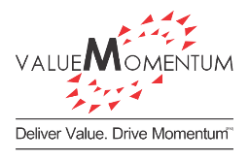

**Test Strategy**

**GEICO Indy COE QA**

**Eric Distler**

IT Manager

GEICO Indy CoE

|  |  |  |  |
| --- | --- | --- | --- |
| Version | Date | Description | Created by |
| Draft | **10/15/2018** | Draft version of the strategy for review with Eric D | ValueMomentum |
|  |  |  |  |
|  |  |  |  |
|  |  |  |  |
|  |  |  |  |

**Table of Contents**

1 Introduction 4

1.1 Intended Audience 4

1.2 Testing objectives and critical success factors 5

2 In Scope & Out of Scope 6

2.1 In scope items 6

2.2 Out of scope of items 6

3 Roles and Responsibilities 7

4 Test automation solution 10

4.1 Overview of test automation solution 10

4.2 Test automation solution architecture 11

5 Testing approach across architectural layers 12

5.1 Overview 12

5.2 UI Tier 14

5.3 Presentation Tier 15

5.4 Business Tier 15

5.5 Integration Tier 17

5.6 Duck Creek layer testing 22

6 Testing life cycle of a user story 25

7 Types of tests 30

7.1 UI 30

7.2 Micro Services 31

7.3 Rating 31

7.4 Forms 32

7.5 Data conversion 33

7.6 Smoke, and Regression – Smart, Mini and Full regression 34

7.7 Performance testing 39

7.8 End-End testing 40

7.9 UAT 41

8 Environments and tests conducted 47

9 Test data management 48

9.1 Technical architecture diagram 48

9.2 Data masking 49

9.3 Stub data in lower environments and utilize true integration data later 51

9.4 Synthetic data generation 51

9.5 Rate testing test data support 52

9.6 Time travel testing test data support 52

9.7 Data refresh 53

10 Metrics and Reporting 55

11 Traceability 61

12 Defect management 64

13 Risks and Mitigation 67

14 Assumptions and dependencies 68

# Introduction

ValueMomentum understands GEICO’s Indy IT COE team’s objective to enable daily releases through complete automation of deployment pipeline, continuous automation testing, and a test automation solution aimed at 100% automation.

Understanding this mission thoroughly, this Quality Assurance strategy outlines the objectives, scope, approach, tool set, environments, process, metrics and governance required to support the Indy CoE journey. This document is intended to establish a shared understanding of the strategy among all the stakeholders and is a living document defined for the evolving needs of the program.

This QA strategy intends to support the objectives of the current scope of the program and its evolving needs i.e. application modernization from legacy to new platforms like Duck Creek for Commercial Lines, rewrite of Mobile services into .Net, migration of the application infrastructure to Azure other such IT CoE initiatives.

This is intended and will be expanded to provide guiding principles for Functional and Non-Functional testing including Performance, Security for various dependent projects that are part of this program.

## Intended Audience

|  |  |  |
| --- | --- | --- |
| # | Stakeholder | What they can expect |
| 1 | Product owner | QA strategy and approach to meet quality objectives |
| 2 | Scrum master | Activities and deliverables from QA team |
| 3 | QA Manager | Strategy and approach to meet quality objectives |
| 4 | Analyst team | Requirements testability expectations, test coverage approach, risk-based testing approach, UAT collaboration, defect analysis and defect prevention approaches |
| 5 | Quality Assurance team | Reference document for specific test life cycle activities, methodology, strategy, toolsets, process, metrics, communication, and reporting |
| 6 | Development team | Quality assurance activities across project life cycle, entry and exit criteria, defect management and collaboration required at various stages |
| 7 | DevOps | Expectations and handshakes required to enable CI/CD and automated test suite integration into build and deployment process |
| 8 | IT Project Manager | Activities and deliverables from QA team |
| 9 | Audit Team | Responsible for ensuring protecting PII/PCI or other sensitive data used for testing |
| 10 | GEICO Manager | Strategy and approach to meet quality objectives |
| 11 | IT Director | Comprehensive approach to quality assurance to support the Indy IT CoE objectives |

## Testing objectives and critical success factors

* **Shift-Left** – to support test driven development practices, integrated with visual studio (Azure DevOps)
* **API/services testing** – to enable headless testing and achieve higher coverage and faster test cycles
* **Test early and Test often-** Leverage the automation solution to create stubs and virtualize services to start early testing while GUI is developed
* **Traceability** – to support rapid test impact analysis across the “requirement – code – test case – defect” spectrum to quickly identify tests impacted by code change
* **Code coverage measurements** – Improve quality with the ability to track code coverage based on the test cases executed
* **DevOps support** – Test automation solution that integrates with CI/ CD pipeline
* **QA architectural governance** - Policies, procedures, best practices and architectural guidelines to design, build and maintain the automation test solution required to support the program
* **Sprint-1 testing approach**- QA team collaborating with analyst team to design and develop test scripts, Sn-1, against the acceptance criteria of the user story
* **Test Impact Analysis-** Leverage automated test impact analysis to identify impacted tests based on the code changes
* **Feature/EPIC test automation-** Progressively string and optimize regression test suite. Regression review board to review the coverage of regression suite to ensure the coverage
* **Test Data Management-** Availability of production like data (with PII and PCI masked data) to test business critical scenarios and data dependent tests.

# In Scope & Out of Scope

This strategy document is intended to provide quality assurance support for all the projects under the scope of Indy COE e.g. Commercial modernization, Mobile services rewrite and other projects. To this effect the scope and out of scope sections are program oriented and are applicable to all the projects.

## In scope items

* Azure DevOps end to end test automation solution development to support
  + User Story, In Sprint, test automation
  + Feature/EPIC level test automation
  + GUI automation
  + Services automation
  + End-to-end test automation
  + Business rules, Rates and Forms automation
  + Smoke, and Regression
  + Performance testing
* Integrate automation solution to CI/CD pipeline
* Automated test execution and reporting
* Defect management
* Parallel testing
* Test data preparation
* UAT support

## Out of scope of items

* Legacy/non-commercial applications automation development/maintenance
* Requirement development and management
* Unit testing
* Security testing
* Test environment management
* Production and maintenance support
* Test data management

# Roles and Responsibilities

|  |  |
| --- | --- |
| Role | Responsibilities |
| VM QA Program Lead (Onsite) | * Responsible for overall QA program delivery * Single point of accountability for metrics * Governance reporting, Risk management, and Estimations * Work with GEICO leads and develop program level test strategy and test plan * Responsible for Metrics definition and reporting along with GEICO leads and managers * Identify and manage changes, risks, and issues within the program and work out mitigation and contingency plans along with GEICO leads * Provide overall coordination among test teams to ensure that testing strategy is executed |
| VM Test Automation Architect (Onsite) | * Consult and identify right fit testing solution * Work closely with GEICO management in identifying solution requirements and create roadmap * Identify technical solution for CI/CD * Provide testing support for applications in terms of technology and tools * Provide periodic status updates to GEICO project managers and ValueMomentum Test manager * Architect solution for code coverage and test impact analysis * Review automation solution code and enforce GEICO coding standards |
| VM SDET (Offshore) | * Implement automation solution using technology and tools identified * Work with scrum teams to identify automation requirements and plan for implementation * Work with onsite SDET and automation architect to plan and implement automation solution |
| VM SDET (Onsite) | * Perform test design, automation and execution for the scrum team * Responsible for scrum testing activities including functional, smoke and regression * Coordinate with all scrum teams for feature level and epic level testing * Participate and contribute in all meetings for the scrum team including release planning, sprint planning, sprint review, demo and retrospective. * Identify and manage changes, risks/issues within the scrum and work out mitigation plans in coordination with other scrum teams * Provide periodic status updates to GEICO project lead, manager and VM Program QA Lead * Responsible for defect triage and tracking defects to closure * Automate test cases * Coordinate with offshore team for all testing deliverables |
| VM QA Lead (Offshore) | * Perform test planning, estimation and execution oversight * Assign and manage work load to offshore scrum testers * Identify and manage changes, risks and issues within the testing and work out mitigation / contingency plans * Plan and track metrics * Provide weekly QA status report to project leadership * Review offshore testing deliverables * Facilitate resolution of queries raised by the offshore team |
| GEICO Analyst team | * Providing clarity on Testing Scope * Involving QA team in the backlog grooming * Test Coverage review and sign-off * Test Cases review and sign-off * Responsible for participating in the Sprint ceremonies * Review and sign-off of QA Strategy * Provide clearly defined Acceptance criteria to QA team * Participate Regression review board for regression test optimization * Review and sign-off E-to-End test plan * Provide requirements and user story clarifications * Identify and provide Test data for critical scenarios * Review of defect summary report and participate in defect triage, defects prioritization, and defect root cause analysis * Review and sign-off of Test Summary / Closure Report |
| GEICO ETF team | * Setting up ETF environment * Own any changes to ETF including new enhancements, change requests and defect fixes * Providing training and support |

Please find below the RACI matrix that has list of all project activities and the responsibilities between GEICO and VM resources.



GEICO Scrum Team includes Product Owner, Scrum master, Analysts, Developers and Quality assurance team

# Test automation solution

To meet the objectives of Indy IT COE and the critical success factors mentioned earlier a test automation solution is designed to

* leverage ETF (Enterprise Testing Framework) testing framework in use today at GEICO
* leverage DuckCreek’s TAC (Test Automation Centre) testing tool
* enhance the combined toolsets with a VSTS wrapper

|  |  |
| --- | --- |
| Tool | Purpose |
| ETF | * UI Testing * Web Services Testing (XML) * Continuous testing support for CI/CD on PaaS * Database testing |
| TAC + Regression runner | * Manuscript testing |
| Visual Studio Solution (C# Based) | * API Testing using C# libraries * Test wrappers for ETF tests to map to code * Web Services Testing (JSON) * Integration with TDM * Code Coverage * Test impact anaysis |

Other tools used in conjunction with the test solution

|  |  |
| --- | --- |
| Tool | Description |
| PowerShell | Deployment automation |
| Postman | Services testing |
| CA TDM | Test data preparation and management |
| GEICO DevOps Catalog Services | Creating application infrastructure on cloud |

## Overview of test automation solution

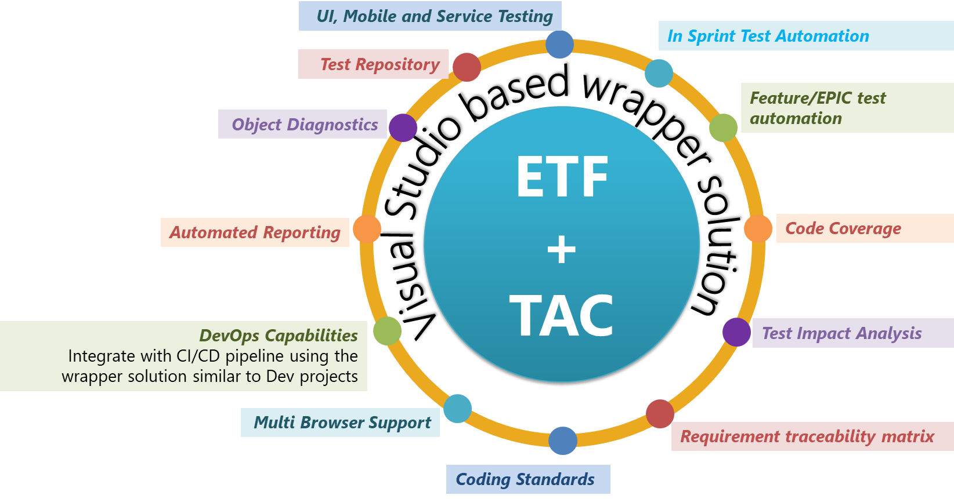

## Test automation solution architecture

**Test solution - components**

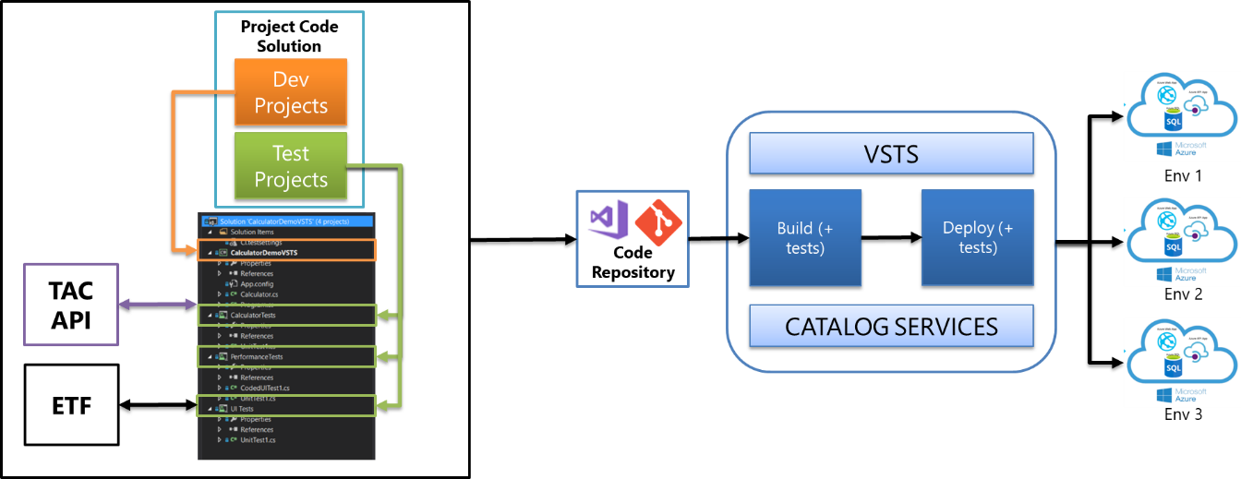

**Testing across environments and code coverage measurement**

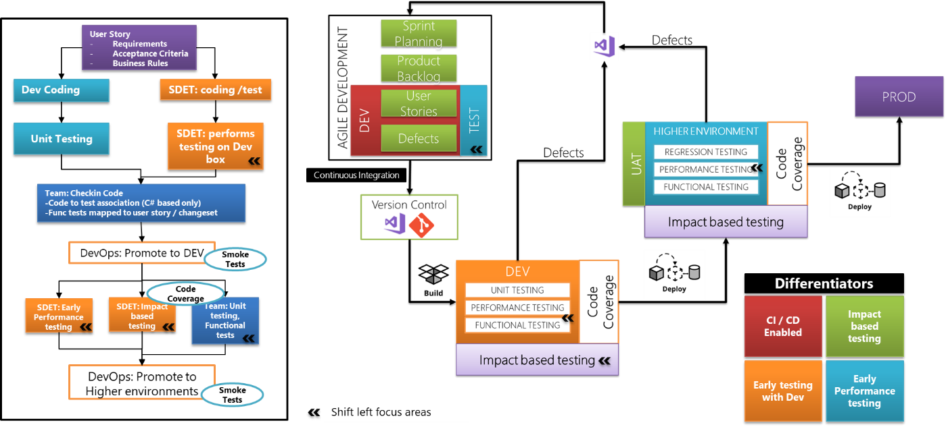

Note: The environments mentioned above needs to be changed according to Indy nomenclature



# Testing approach across architectural layers

## Overview

Following diagram is a representative architecture of a typical modernization program and the test strategy catering to the different architectural layers. Through the approaches specified for these architectural layers, the strategy document establishes a uniform approach to testing multiple needs the Indy IT COE is going to support.

Also, included is a representative architecture of a services layers that is serving multiple front end. Mobile services rewrite project and other similar needs are catered through this approach.

Applications that use all or few of these layers can benefit from the approach recommended in the test strategy document.

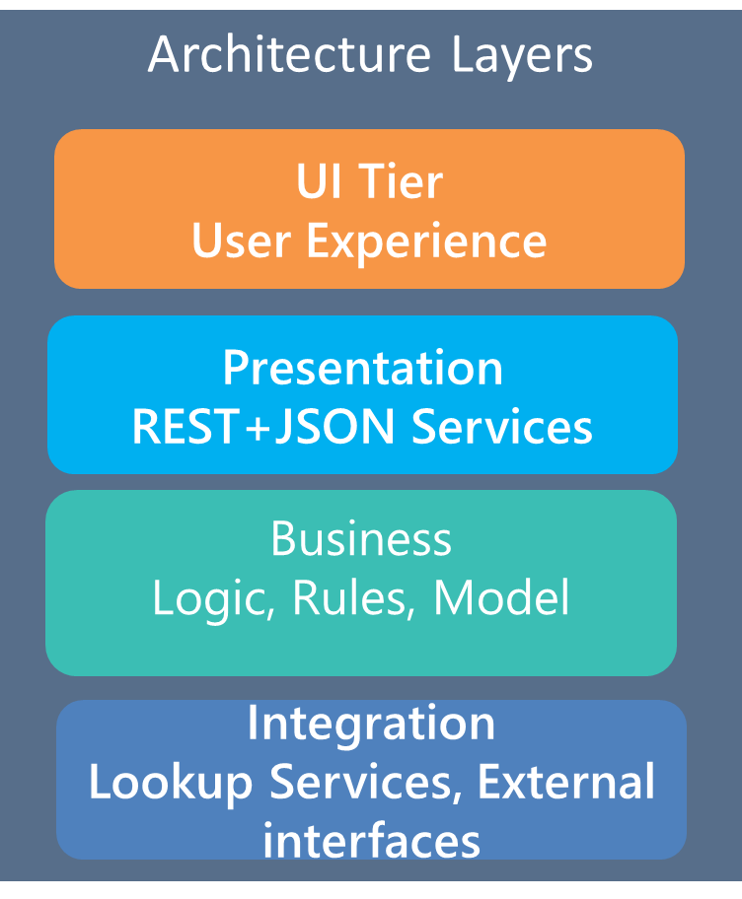

## UI Tier

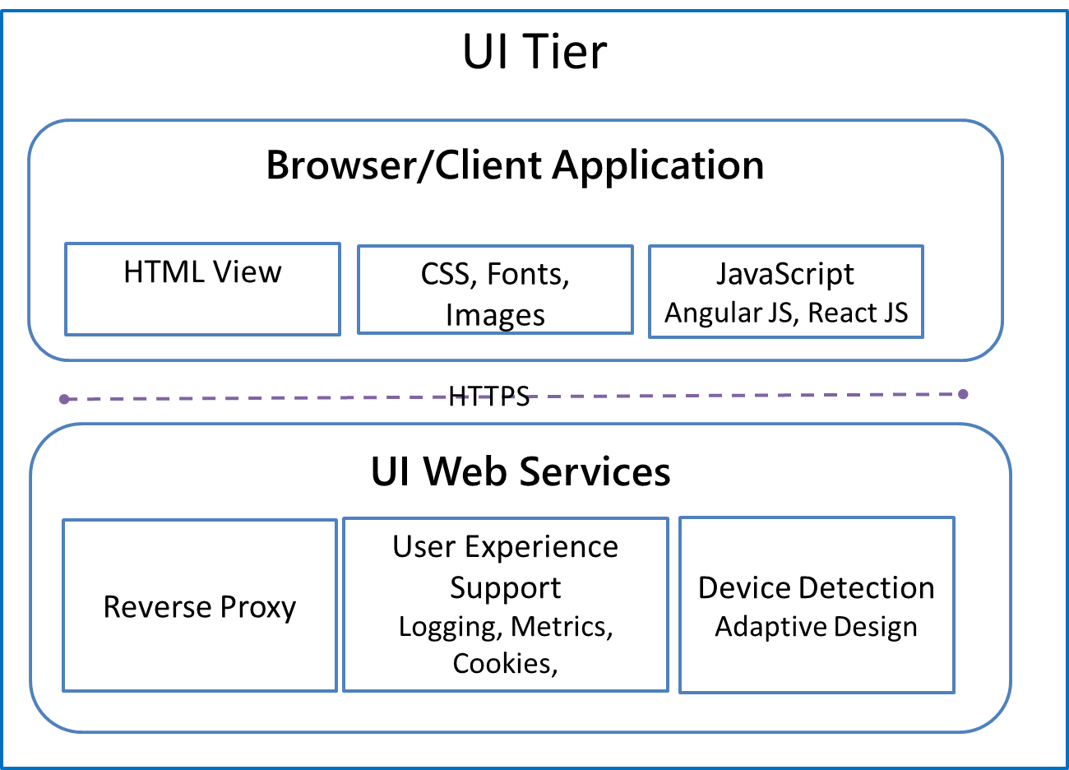

It is what customer views in the browser and there is no business logic in UI tier. This layer primarily controls how the user experiences with the application (check box, list box or test box, radio button, colour of page etc.).

**UI Tier test coverage includes**

* UI validations against view spec
* UI validation rules
* Field level validations
* UI workflows and role based access
* Responsive design

**Responsive UI testing:**

Testing team will use Chrome with Dimensions extension as the primary tool to test the multiple form factors of the application. A subset of test cases will be executed on actual desktops / tablets / Mobile prior to completion of the Release.

Functionality will be tested across these form-factors using the automated scripts that execute tests on various sizes of browser through resizing the browser window.

The three view ports that are planned for testing are:

* Desktop (960)
* Tablet (768)
* Mobile (480)

**Cross Browsers Testing:**

A certain percentage of test cases (% of test suite) are distributed across the browsers with Internet explorer and Edge given the higher priority. The priority will be reviewed based on the usage metrics from the Adobe analytics team.

Browsers included - IE, EDGE and Chrome

**Tool**: Primary tool used will be ETF for testing

**Mobile testing:** ETF will be used for Native app testing. Currently, GEICO testing methods team is migrating the nGraf mobile native app test cases to ETF framework.

## Presentation Tier

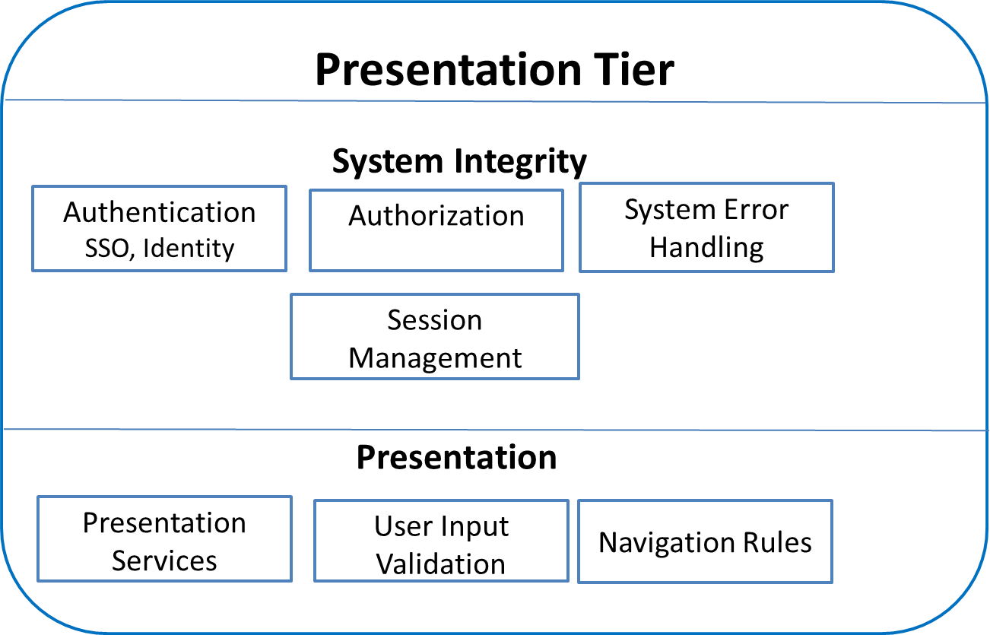

## Business Tier

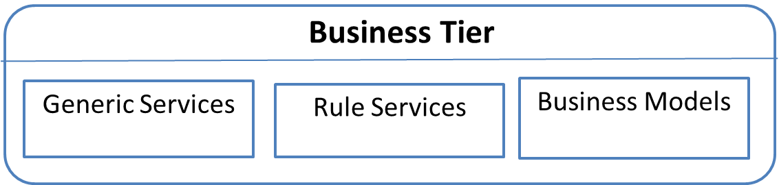

A typical business services layer consists of application logic built in individual services or a platform like Duck Creek exposing the functionality as services. Two scenarios are elaborated below that are relevant to the Indy IT COE.

Duck Creek layer testing is explained in detailed

Mobile services rewrite program is a business tier logic that needs to be tested comprehensively and also parallel tested against the Java services layer that is replaced

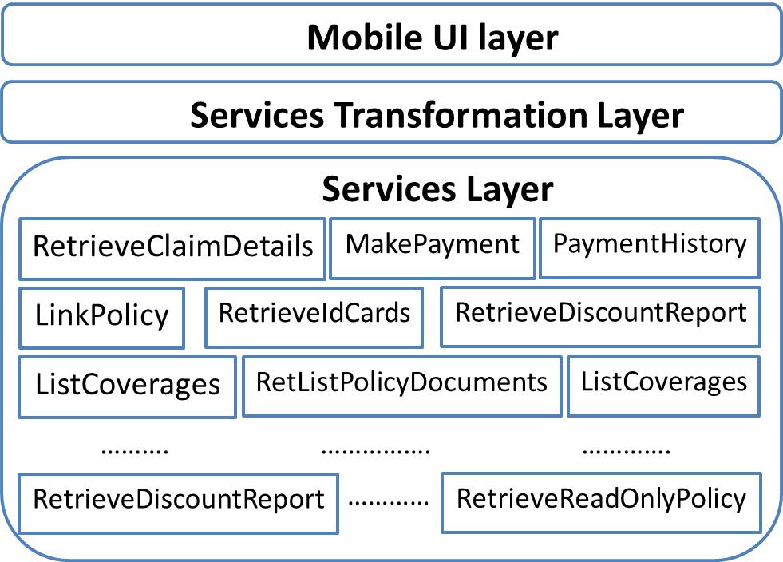

Each of these services are being developed as a user story under a Feature that is under and an EPIC as shown below



Scope of testing of these services include

1. Functional automation testing of the .Net service
2. Parallel testing and comparison of the service output against the existing Java service

**Functional testing of User story** is explained in earlier section. In particular to mobile service, the testing conducted is completely micro services based testing. Below are the key consideration for testing these services

* Test cases for each of the user story cover the acceptance criteria defined
* Traceability to User story to test cases/ scenarios is provided by QA team
* Automation test cases for each of the user story are checked in and executed as part of the deployment pipeline (user story unit test cases are executed as part of build pipeline)
* Test cases for each of the user story cover the scenarios expected from the calling mobile application workflow
  + A dependency map needs to be prepared (during the test design or user story elaboration) that has mapping of User story to Mobile workflows
  + A dependency map needs to be prepared (during the test design or user story elaboration) that has mapping of User story to other dependent services
* Existing test cases, test data variations and expected results are reused and rewritten (into the VSTS test solution) to enable continuous integration and testing

**Parallel testing of User story** of the service is done as below

* Each .Net service output is compared against the existing Java service for the same set of test cases and test data variations
* A comparison report is submitted during the Sprint
* Parallel testing is conducted through manual and automation approach

## Integration Tier

ETF and the custom VSTS wrapper solution will provide support Mobile testing by integrating with mobile testing platforms like Mobile Labs. This will support Mobile web and native applications.

ETF and the custom VSTS wrapper solution will provide support Web Services testing by invoking a web service and compare the response XML against expected values.

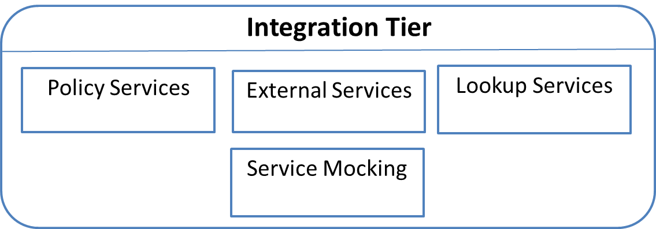

**Positive flow:**

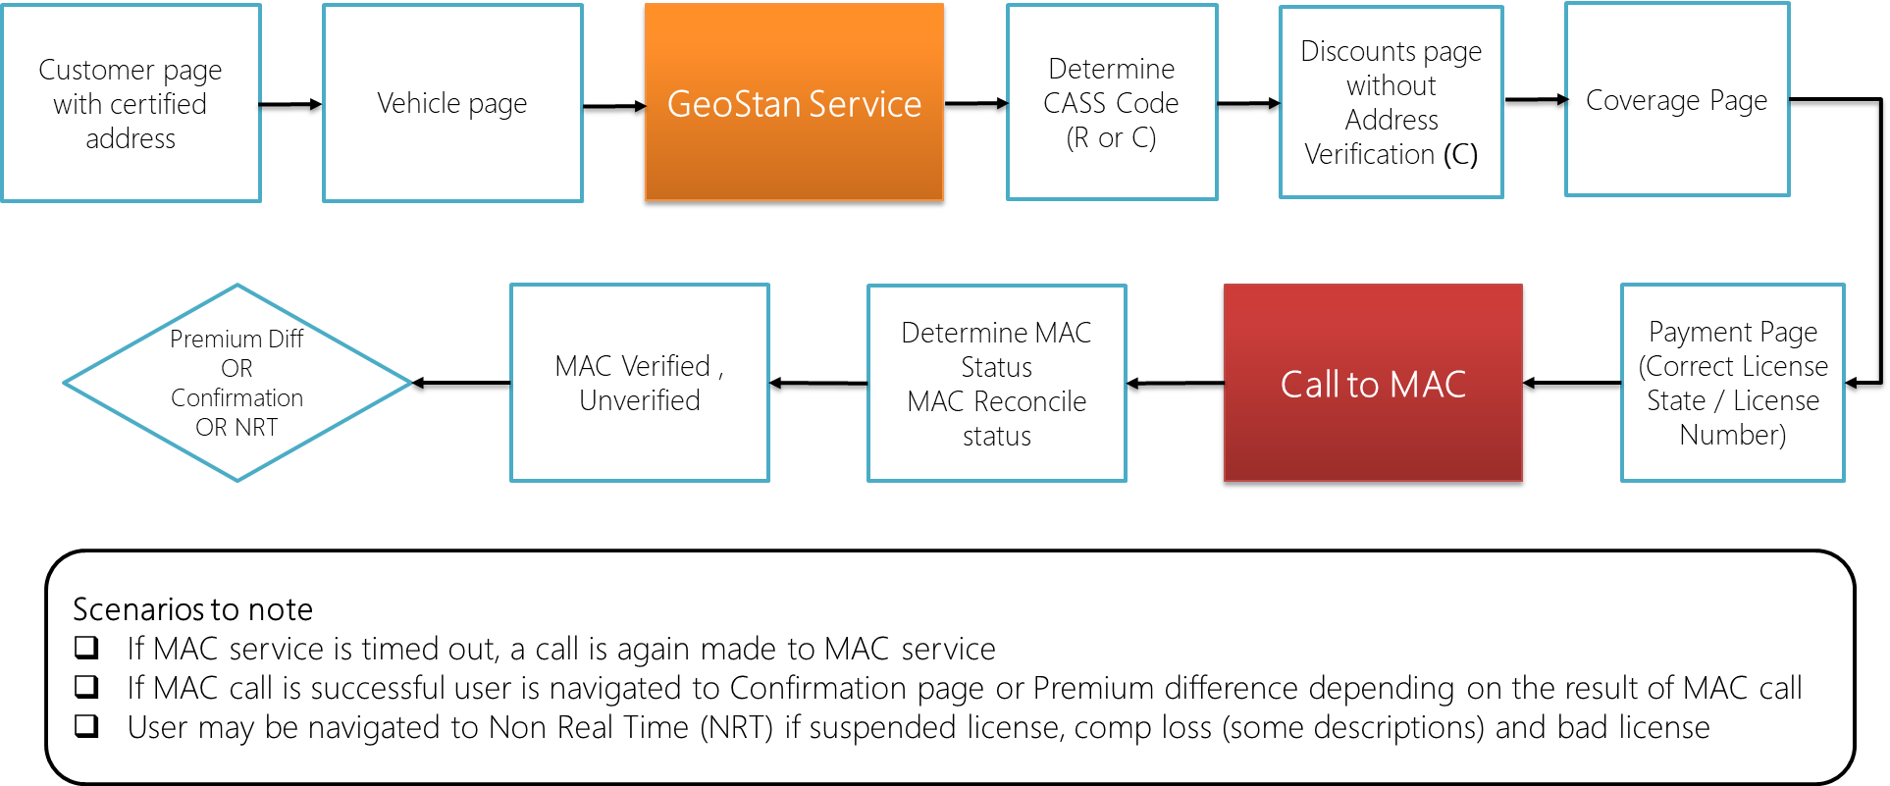

**Negative flow:**

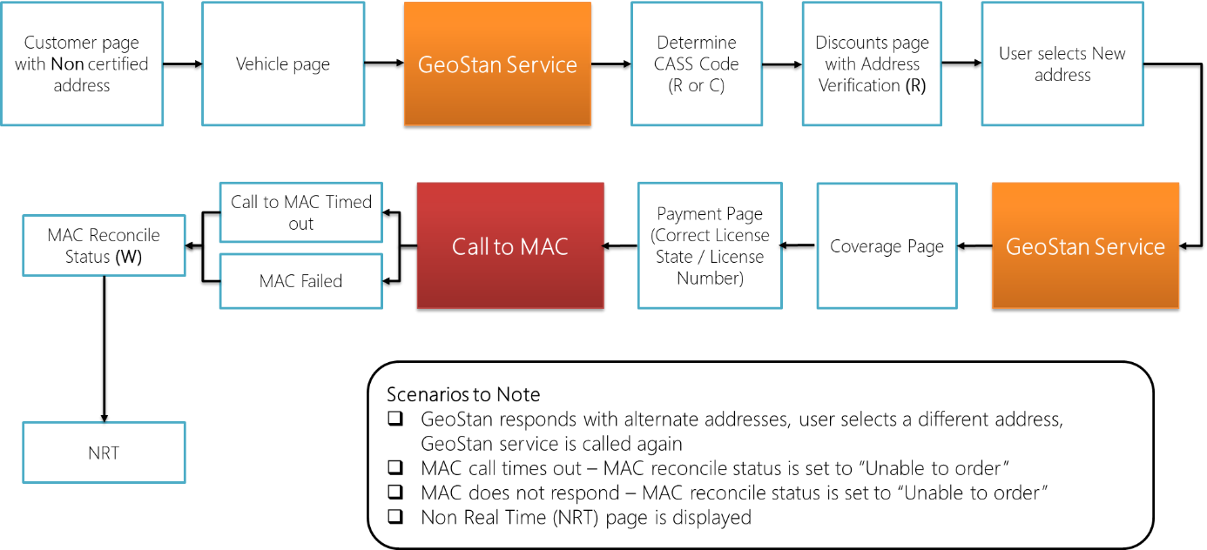

**Leverage application rules as part of the test cases to test services:**

Intercept the service calls through fiddler and validate the input and output data going to the respective service

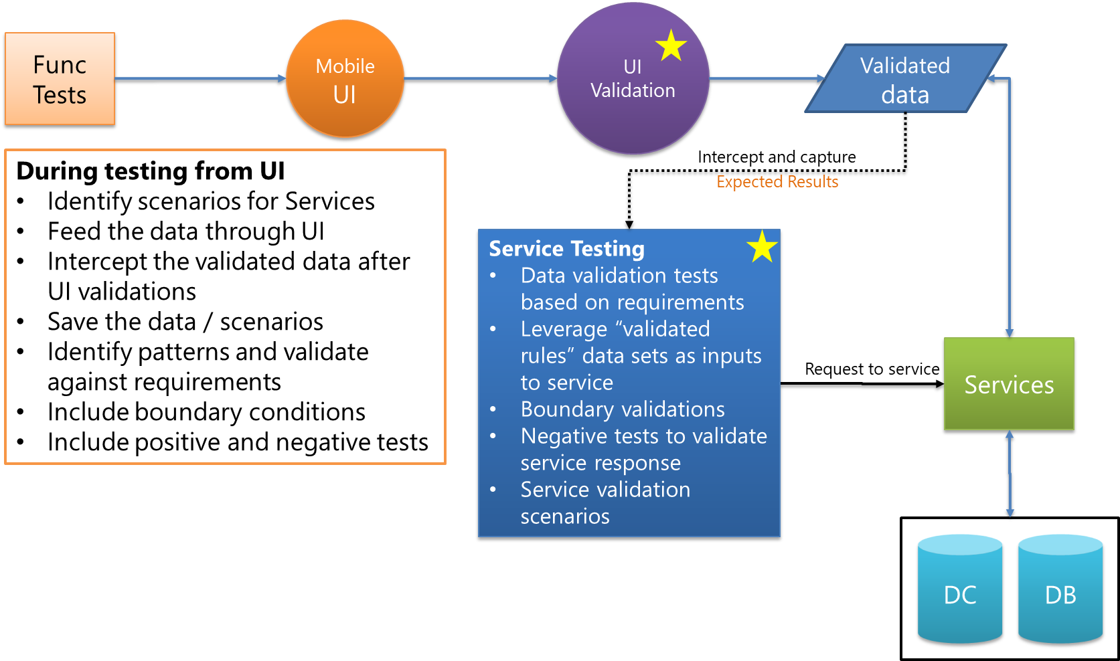

Integration layer will make a call to all downstream and interfaces such as policy services, address lookup, vehicle, driver records etc. in order to get the response back to client.

These tests will be invoked from 1) UI layer 2) direct call to the services

* UI layer- identify the respective scenarios that will invoke the underlying services. For e.g. address field- Garage address validation, system will make a call to Geostan service
* Direct calls to service- identify the endpoint and based on the contract of the service, prepare the request and use Fiddler to make a direct call to the services or dependent services to test all the responses (both positive and negative response)

Virtualize the service that are not developed fully, either using CA LISA or write custom C# logic to test  it. E.g. Add reference to Mock4Net.Core to your test solution

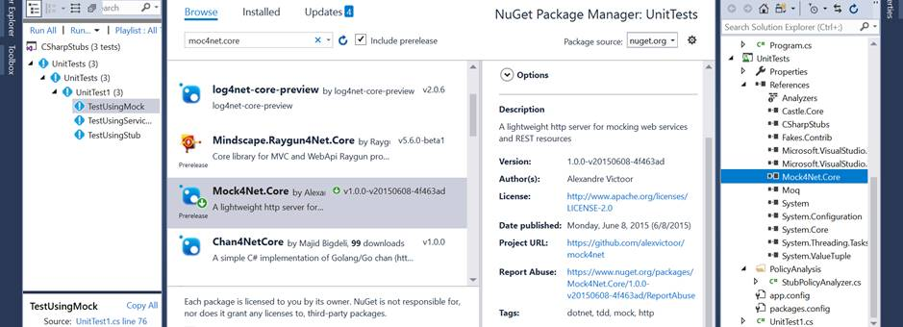



**Mock testing of services:**

Mock object simulates or mimics a real object. It has the same interface as the real object so the client (Our method is the client here) can use the mock object in the same manner in which it uses the real object.

Moq is helpful when there is an external service which we are using in our code, if we are doing testing for a method which internally calls the external service, then we have to wait for the external service.

To use the Moq (mocking framework) in our application, we need to follow the below steps:

1. **Add a reference to the Moq (one time step only)**

To use the Moq library in the project we need to install Nuget package for Moq

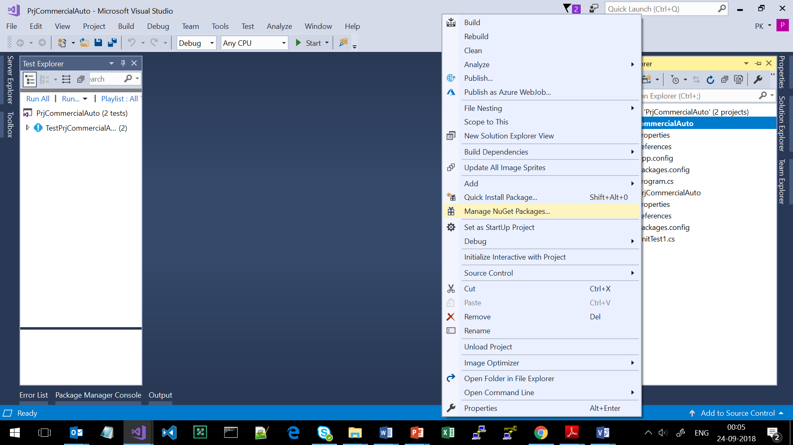

Type Moq in the Browse and select the Moq, click install

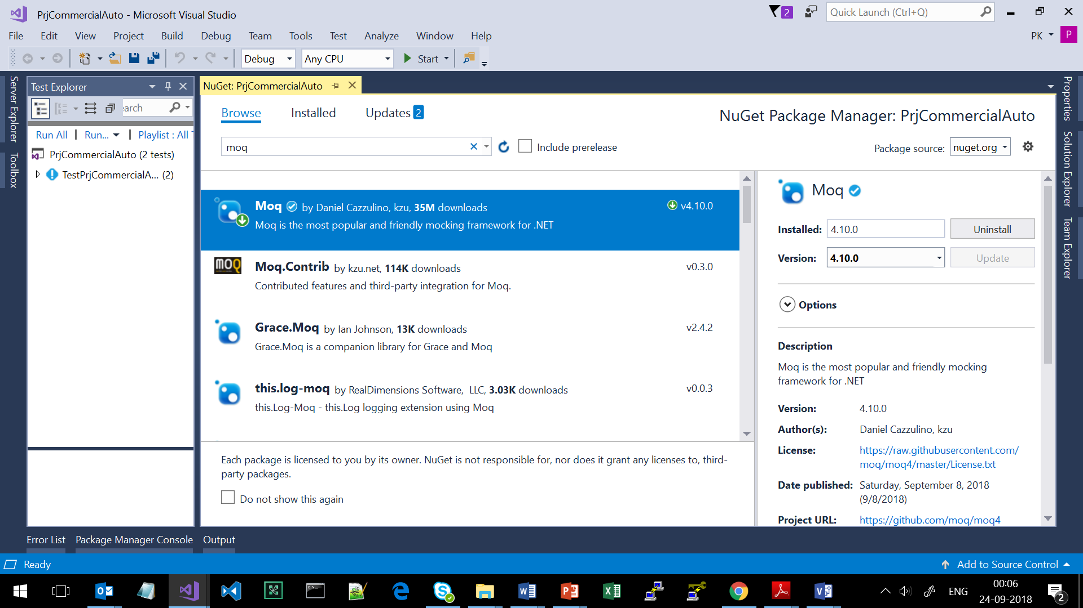

1. **Import the Moq namespace (one time step only)**

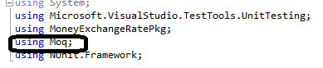

1. **Create Mock object**

We need to tell Moq what type of object we want to mock. We do this by passing the type of parameter to the Mock generic type as:



The above line tells the Moq library that we are mocking the “TypeToMock” type. We create a mock object for a specific type.

1. **Setting the expectation or behaviour (repeat step)**

Moq uses lambda expressions, generics and delegates which makes Moq suitable for .NET applications. To define the behaviour, we use the Setup method as:



The above line demonstrates some of the important concepts used in the Moq mocking framework. The three main methods used above are:

1. **Setup ():** Used for defining the behaviour of a method. The above code is setting the behaviour of the MethodName method.
2. **It.IsAny():** “It” is a static class containing various methods used to set the parameter expectations. It.IsAny<int>() means the method will accept any parameter of integer type.
3. **Returns():** This method is used for returning values from the method passed in the Setup() method. The above Returns() method will return a null when the “MethodName” method is called with an integer value.

The Setup method is passed a parameter of the type of “mockType”, so we can access the methods and properties of the mockType in the Setup method. In the above code, we are defining the mocking behaviour for the MethodName() method.Returns() method defines the result which the MethodName() method will return.

## Duck Creek layer testing

There are **several dimensions (variables)** such as State, Transactions, User Role that the determines test coverage for each line of business. The purpose of testing is to validate Transact, Rules, Rating and Forms across these dimensions for a Policy.

Test strategy includes validation of carrier specific variations in the areas of:

* **Workflow rules** - For all product offerings
* **Rating rules** – Verifying Premiums, surcharges and discounts for the policy
* **Form -** State, coverage level and other applicable forms for the policy

Test scenarios will not be specifically designed for out of the box (OOTB) rules. However, they will be validated (OOTB Rating rules, Forms and Workflow rules) will be validated if they are part of the output of test execution.

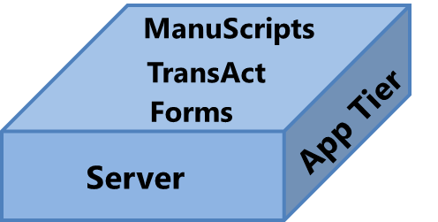

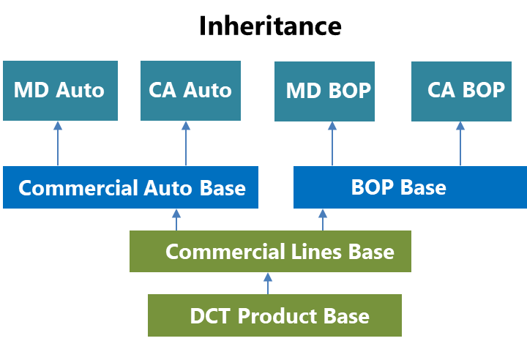

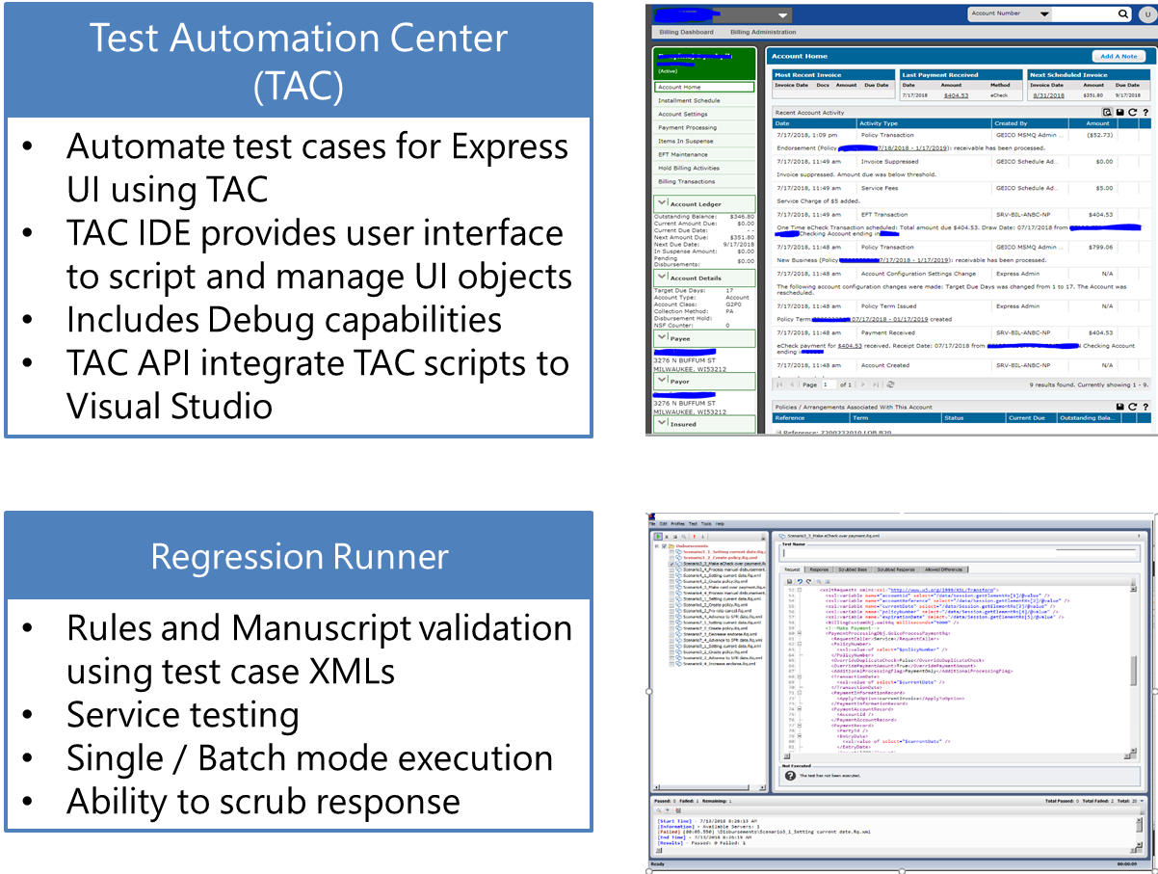

Note: Test activities mentioned does not include Express UI validation as Express UI is not used

**Sales transactions:**

Focus is to perform validation for Workflow and TransAct rules across policy transactions and for all product offerings

* Validate transactions in the policy life cycle for all lines of business as specified in the TransAct business requirements.
* Validate workflow referral and task rules for all the transactions in the policy life cycle.

**Service (Post New Business) Transactions:**

Validate the automated renewal process as per business requirements in the Duck Creek application

* + Test scenarios should also include negative testing for policies that do not automatically renew based on renewal requirements.
  + Validate the automated renewal rules with and without policy change.
* Identify major transactions and prepare a check list for all interfaces and integration points and design test scenarios to validate the transactions
* Develop test cases for out of sequence scenarios.
* Transact need to be tested as service using the Duck Creek API. Test scripts will be created and executed in Fiddler/SOAP UI.

Create a good sampling of test data that represent production policies. This will be used for regression testing. Test variations can be accomplished through Automation

# Testing life cycle of a user story

An overview of user story testing across Sprints in depicted below

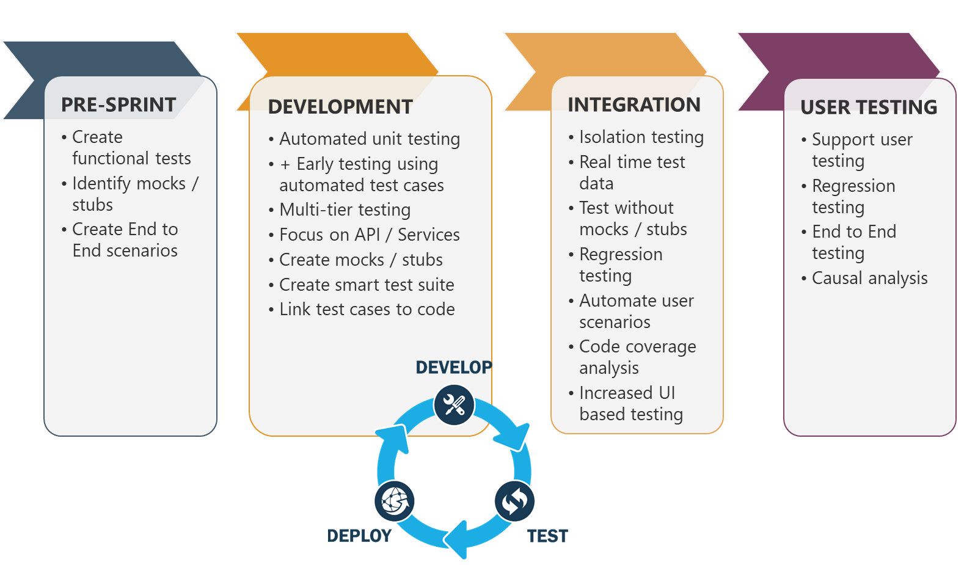

Each user story that is tested will have clear and documented traceability using Azure DevOps which will consist of the following criteria:

* QA team will work with Analyst team to conduct a requirement feasibility analysis from testing stand point and get a detailed understanding of the acceptance criteria defined for the user story
* QA team will design scripts early (Sprint-1) by collaborating with Analyst
* Test case execution begins when the User Story State is Dev ready
* Each Scrum team is responsible for executing all test plans within the two-week sprint to fulfil the Acceptance Criteria.
* QA team and Analyst team will collaborate as per the define framework below:

* QA team will work with GEICO team to establish a Regression review board (comprising of Feature owners, Analysts and QA team). The objective of having a Regression review board is to review the size of the regression suite is optimal yet ensuring test coverage is not compromised. This effort would require collaboration from all Scrum teams involved in testing.
* Test cases from current sprint are reviewed and a subset of them are tagged as “Regression”
* QA team will create an automated smoke test suite, that will be integrated with the CI build. This test will be executed post every build/deployment.
* Link all test cases to their respective user stories (“tested by” link)
* Clearly document/link/or attach test execution results to ensure the test data and steps were successfully executed.
* Defect is opened, if the test cases fails, and linked to User Story and Test Case(s)
* Testing of a User Story is complete once all test cases are executed and passed and meets the Definition of Done criteria
* The Definition of Done (DoD) is a clear and concise list of requirements that all scrum teams must adhere to call a story or sprint complete.  Following the DoD ensures all tasks are consistent among teams and all deliverables are complete.  The Definition of Done is not changed during a Sprint but can change periodically between Sprints if improvements or changes are made in the team’s processes and capabilities to deliver software.

Sprint- Definition of Done

|  |  |
| --- | --- |
| All User Stories Closed | All user stories are closed according to the Story Definition of Done. |
| Regression Testing Completed | Regression test completed on previous functionality. |
| No Critical Bugs Open | All Showstoppers and Critical Issues must be closed. |

* Test cases are optimized and/or combined to maximize test efficiency- this is done continuously along with analysts
* Test Cases are created at both User Stories and Epic Level :
  + User Story Level Test Case will test the acceptance criteria of a given user story at a granular level in isolation
  + Epic Level Test Case will test the meaningful functional/business flow accomplished by the collection of user stories under the Epic
* The Test Suite will comprise of multiple types of tests , creating a robust collection of reusable tests :
* In subsequent sprints, testers should open tasks to execute past User Story tests as “regression”.
* Suggested Test Case States – Design, Ready, Completed, Closed
* Design – Test Case being created
* Ready – Test Case ready for execution
* Completed – done, but not closed
* Closed – Testing completed, regression review needed, moved to backlog
* When a user story is not delivered or delivered late to testing team within the given sprint, User story will be moved to the next sprint backlog for testing
* When a user story acceptance criteria or requirements changes after it is tested by the testing team there will be additional effort required by the testing team to assess the change, write additional scenarios and perform testing

**Details of activities performed in each Sprint:**

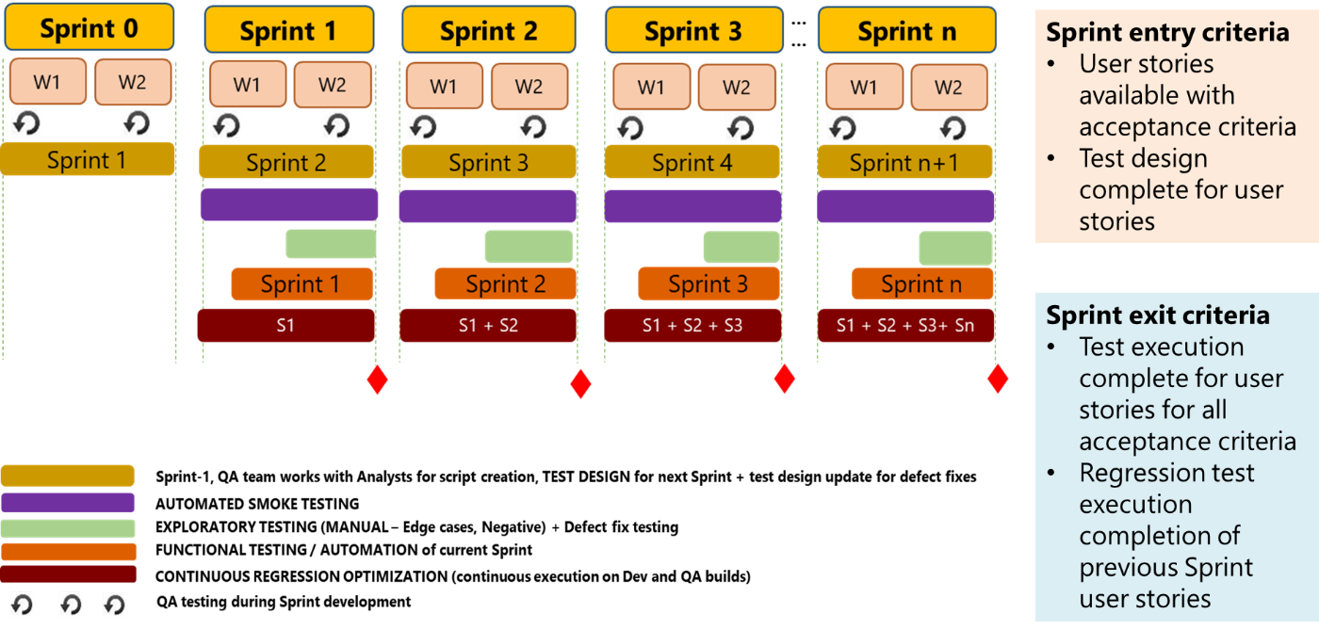

*\*integrated test frequency in respective environments, to be determined based on the #of builds/deployment plan (multiple times a day/ per day one or alternate day deployments etc.)*

**Following diagram depicts various testing activities that testing team will perform during Sprint level and Release level**

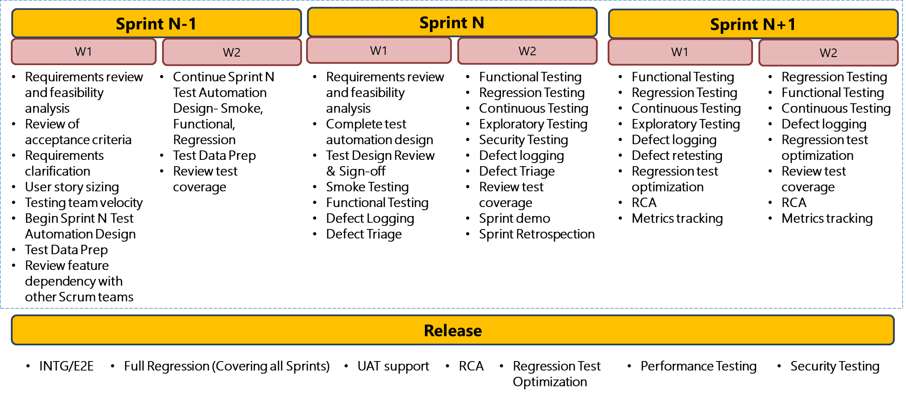**Test Execution**

Test execution will start once the code is promoted into test environments and smoke testing is successful.

Exploratory Testing is performed in addition to test automation; that is while automated checks are checking for regression issues. Exploratory Testing focuses on new features that are developed and is carried out in every iteration/sprint in Agile.

Exploratory Testing ensures Test Coverage of potential real-time issues which are normally not a part of Scripted Testing Scope.

Exploratory testing needs to be broken into two aspects

1) Structured – Example: Compliance requirements or alternate workflows that can defined in a charter (implicit requirements or edge cases)

2) Unstructured – Example:  Break testing, Agents open Navigation and repeated clicks on buttons randomly etc.

In Order to effectively uncover such issues, Exploratory Testing is jointly performed with users or analysts, preferably, using standard approaches like Session Based Test Management Approach (SBTM Cycle)

1. Create a Bug Repository

* Categorize Common types of bugs found in past projects or Real Time User Experience
* Analyze Root Cause

1. Coordinate with analysts/ end-users/ region users and obtain the expectations from the systems e.g. Compliance requirements, User navigation workflows
2. Prepare an Exploratory Test Charter (What to Test & How to Test )
3. Perform Time Boxed Exploratory Testing
4. Review Results (Compare Results with Testing and Identify further testing needs)

Any defects identified during testing will be logged in the Azure DevOps and traceability is established all the way to the test cases & user story. Defects undergo triage process explained in document. After the meeting the exit criteria, a detailed QA report including execution and defects (mitigated/fixed), will reviewed with business analyst for approval and test closure & acceptance.



# Types of tests

## UI

UI testing is performed during the implementation phase to validate the configuration of various components such as fields, screens, navigation, and rules

Screen based test cases will primarily focus on testing the behaviour of the objects within the screen including their functionality and the defined business rules.

Key validation Includes

* UI Fields / Dropdown’s validation
* Application Workflows & Policy transactions
* Business Rules
* Underwriting rules
* Transactions
* Role based access

Application workflow testing technique encompasses Positive and alternate workflow validation of transactions to ensure that each workflow process accurately reflects the business process.

ETF is used primarily for UI testing.

**Proposed test automation process using the ETF solution**

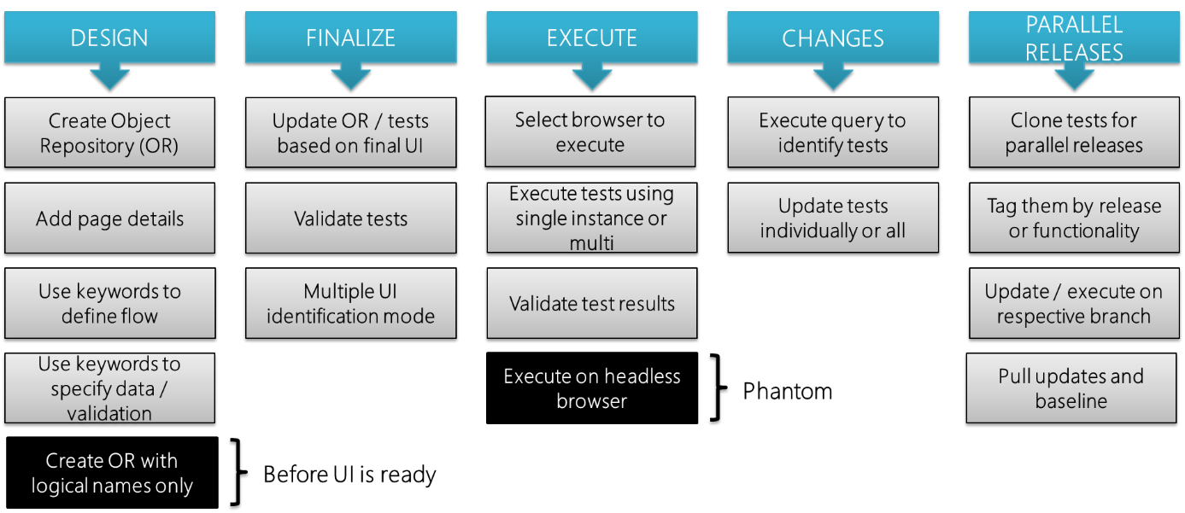

Find attached the ETF user guide for QA reference.



## Micro Services

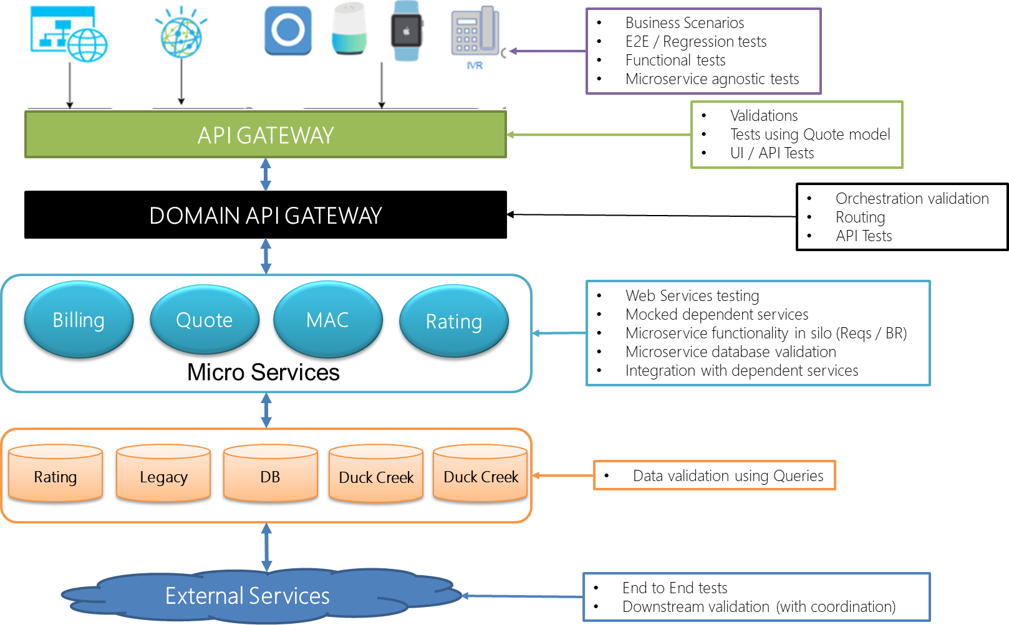

## Rating

Rating testing is embedded within DuckCreek rating engine. One significant assumption that is made towards this rate testing strategy

1. Rates are same as in Insurity system – no change in coverages, rating tiers, rate factors etc.
2. ISO commercial auto rates are implemented- reference manuals and rate tables are available for the analysts and QA team
3. Existing rate test cases, calculators (if any), rate testing results are used for comparison testing

One of the significant activity in rate testing involves preparation of a rate calculator that is used as version of truth for comparison. This is utilized for a 3-way comparison to minimize the debugging time and avoid confusion of which system is correct

1. Using existing Commercial lines implementation of Insurity as point of reference
2. Using existing test data (scrubbed production policies) for input and comparison of output
3. A rate calculator is prepared with all the rate and algorithms and made as a point of reference- version of truth
4. This calculator is seasoned with production policies to make sure it accurately reflects the correct expected rating behavior
5. This calculator is validated with business analysts and users to ensure it is the “version of truth”
6. Test data available from scrubbing of production polices is used for testing against the three models
   1. Insurity system
   2. Rate calculator
   3. Duck Creek rating system
7. Most of the cases, all three return the same value. Else, the system that has the defect will show itself and developers can debug the same
8. Test team will prepare the rate calculator and arrange sessions to demonstrate and validate with business users
9. Rata specifications and rating algorithms are provided to build the rate calculator

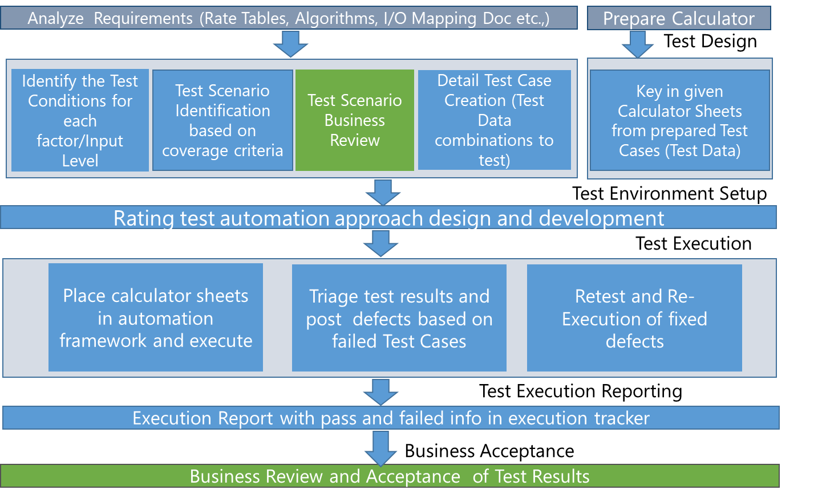

## Forms

Forms output generation can be either in Duck Creek or externalized via a CCM solution e.g. Exstream. The following approach is detailed with a federated architecture in mind i.e. Forms output externalized to a CCM solution. A subset of this approach is applicable in case the document output is contained within Duck Creek.

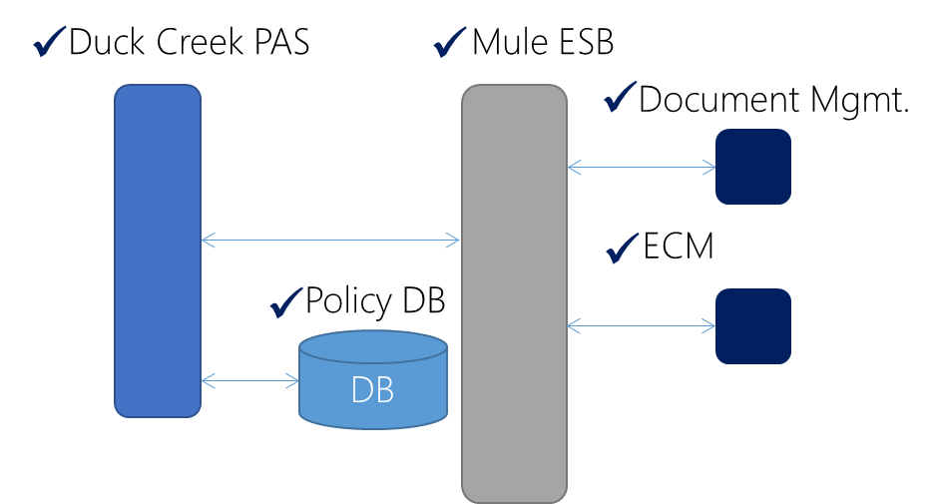

* Validation of prioritized business scenarios on PAS application from an end-end scenario standpoint
* Retrieval of Forms from Document storage through service requests
* Validate documents generated through service requests made to Document generation engine via ESB
* Provide various combinations of Policy data towards
  + Forms Generation Testing
  + Form Content Testing
  + Form Layout & Aesthetics

## Data conversion

Below is a representative architecture of a typical policy data conversion/ migration. QA foot print and associated activities are detailed. The specific of particular database e.g. SQL Server 2012 will be updated further as the details are available.

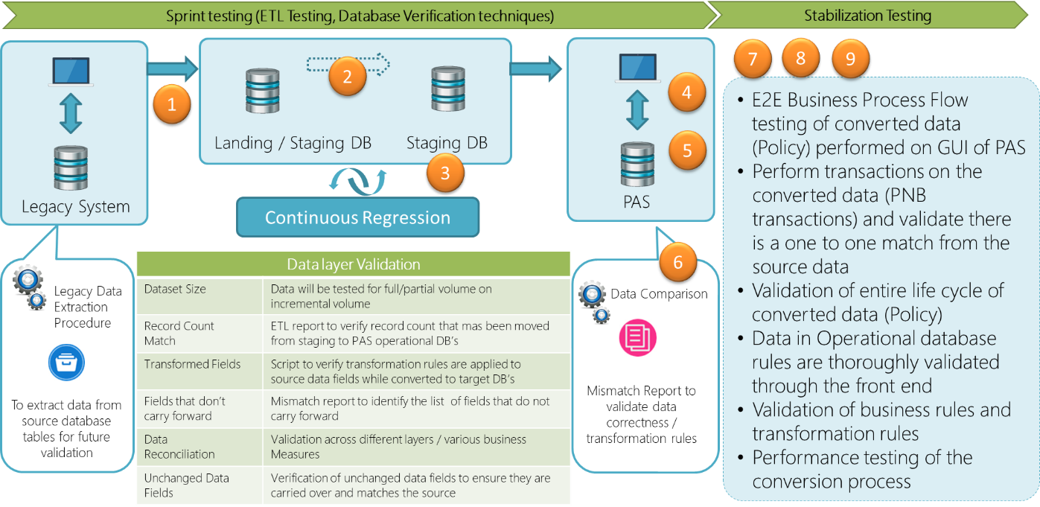

1. Testing of data mapping from legacy to landing area
2. ETL Testing across Layers
3. Database Testing
4. UI validation post conversion
5. Data transformation & business rule verification
6. Record count for Polices converted
7. 7, 8 & 9 – Performing full life cycle transactions on converted data, including performance of conversion (especially for large volumes of data)

## Smoke, and Regression – Smart, Mini and Full regression

**Smoke Testing:**

These are high-level tests to make sure no major issues would prevent the build from moving to the next environment for further in-depth testing by the Test Team. These tests will be agreed upon by Developers/Analysts and the Test Team.

Failed smoke test cases will be investigated by analyst/developer to check for correct severity and priority. Smoke test execution should automatically start once a new build is pushed to the Test and QA environments.

Test Team is responsible for following up on those failed test cases and report accordingly to management.

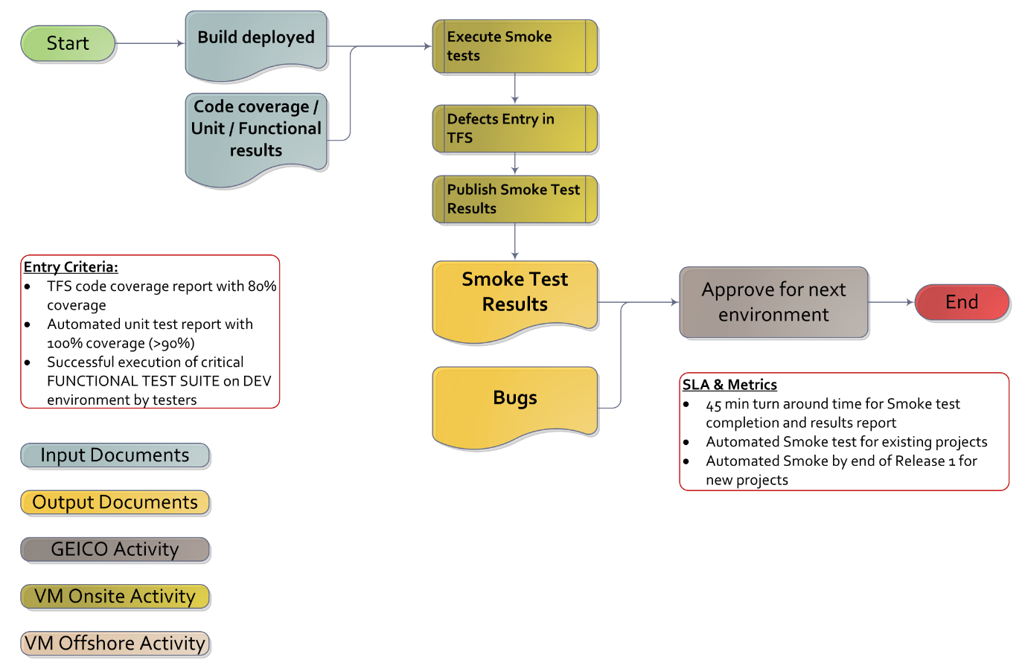

**Regression testing:**

This test validates that the current build still operates according to the specification and is used to catch unexpected negative impacts that occur because of modifications to the system. The regression test suite is built continuously and progressively for every sprint. All tests are included as part of Regression suite. Full regression suite execution every sprint (time permitting) and during stabilization phase of a release.

**Mini regression**: is a subset of the full regression suite comprising critical functionality that must pass before signing off on a Sprint/Release. This is built based upon the functionality that is critical and which is derived in consent with the Analysts. Mini Regression is only used in place of full regression due to time and resource limitation. Following are the factors for test case identification as part of mini regression suite:

* User stories marked as critical
* Feature level e2e tests (combined from one or more scrum teams working on that feature)
* Acceptance criteria that are focused on business rules not field level UI validations
* Impacted changes in the features or user stories that are marked in that Sprint
* Features or user stories having more defects
* Edge cases – covering positive and negative tests
* Features that are integrated with external systems or downstream

Below diagram show the process of building regression suite as the Sprint progresses. Other key considerations include optimizing the test suite at EPIC level and functional test scenarios are release level.

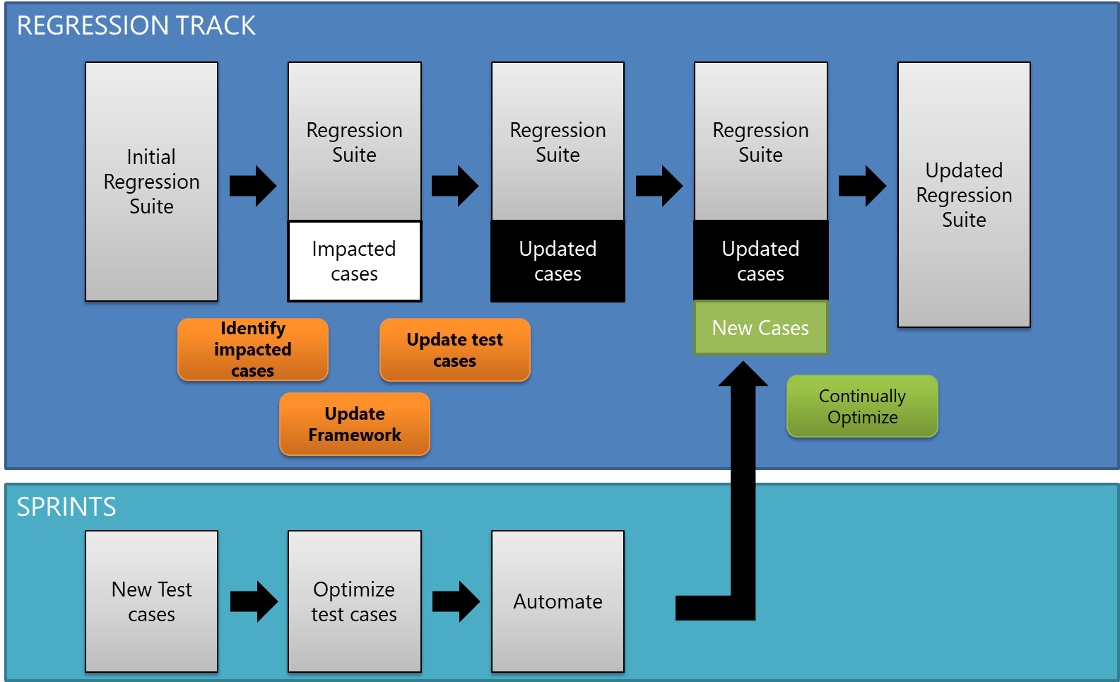

**Smart regression:** Smart regression enables QA team to reduce the test cycle time significantly. QA team will consider the following approaches in order to achieve the goal of building a smart regression suite:

1. Leverage the TIA (Test Impact Analysis) feature in Azure DevOps as part of creating the pipeline to identify the impacted tests based on a code commit. This is an automated process (detailed steps with screenshot are described below)
2. Identify a critical set of tests that has higher impact on the application and will create a mini regression suite. This is manual process and is done with collaboration with PO and Analyst team
3. Nightly build run 2 parallel tests= In a nightly build (non-time sensitive deployment) definition configure 2 test tasks and Run – one for impacted Tests (Task1) and two to run all tests (Task2)

TIA works on the following approach (to pick the impacted tests):

* The existing tests impacted by the incoming commit.
* Select previously failing tests
* Newly added tests

Follow below steps to configure TIA/Smart regression in Azure DevOps:

**Configure continuous integration**

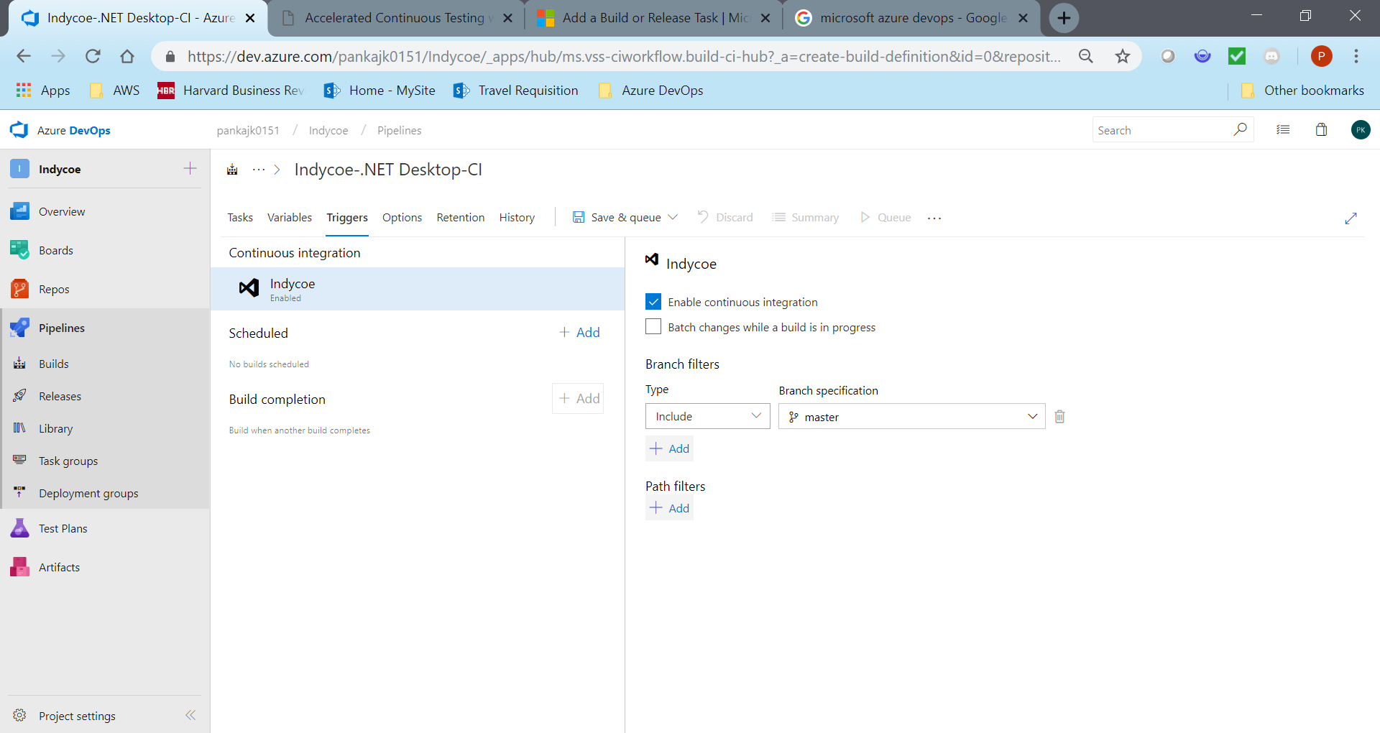

**Configure Impacted test**

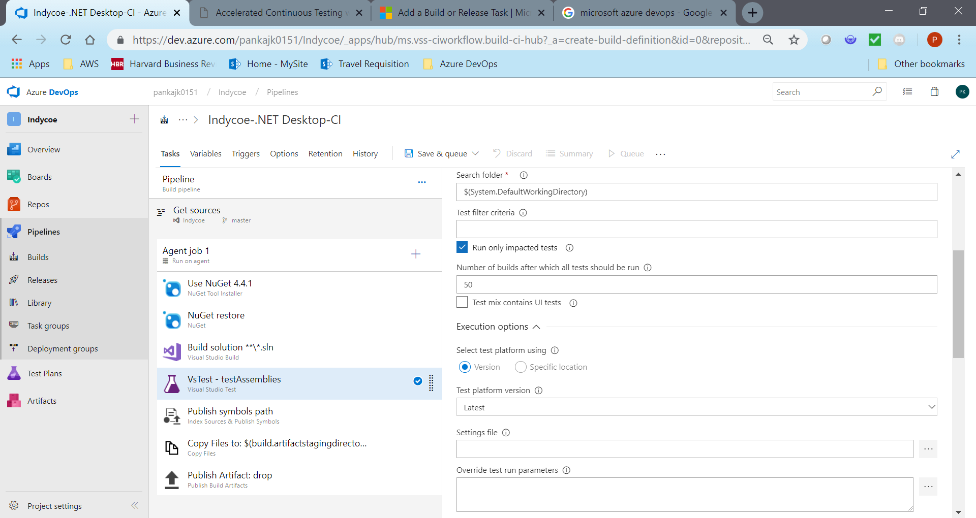

**Regression optimization process:**

While the Scrum teams spend significant effort in analysis and test design of functionality for a given Sprint, it is necessary to optimize the test cases before they become part of continuous integration suite. The approach suggested below takes into account the optimization from the perspective of coverage optimization and the need to integrate test artefacts due to iterative nature of Sprint functionality.

* Scrum test teams tests functionality delivered as part of the scrum team during the sprints
* On completion of functional testing, a separate team is formed from existing scrum teams (added responsibility to the chosen ones in addition to their Sprint responsibilities) to optimize tests for continuous testing (The capacity impacted due to this activity is factored during estimation of sprint activities)
* Test cases across scrum teams are stringed together based on navigation flow and scenarios to form a complete flow of a feature / epic
* Test data is updated, as necessary, for optimization across functionality
* Test cases formed will be prioritized based on this.
* All continuous automatable test cases will be automated based on priority
* Test cases with unique objectives will not be consolidated and will be executed standalone
* All test cases will be mapped to features in VSTS
* All identified test cases will be traceable to user stories
* Finally, continuous testing suite will be shared with Analysts / Product Owners / Scrum master and feedback (if any) will be incorporated

*Diagram depicting optimization process*

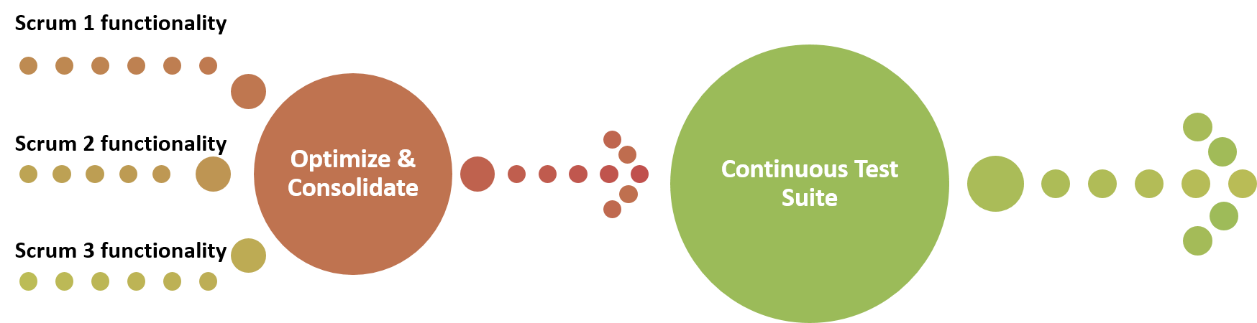

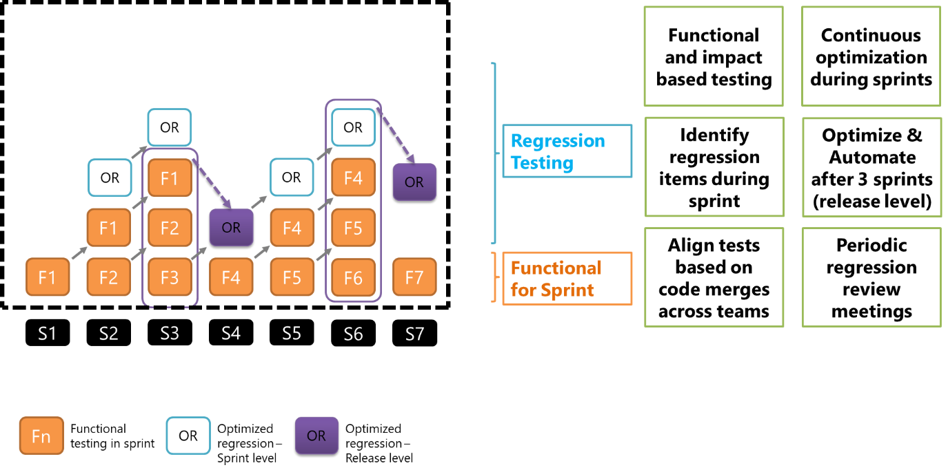

## Performance testing

Azure DevOps (VSTS) will be used for performance scripts developed by the QA team. These scripts are integrated along with functional test scripts. Each user story test design includes functional and performance test scripts as part of acceptance criteria.

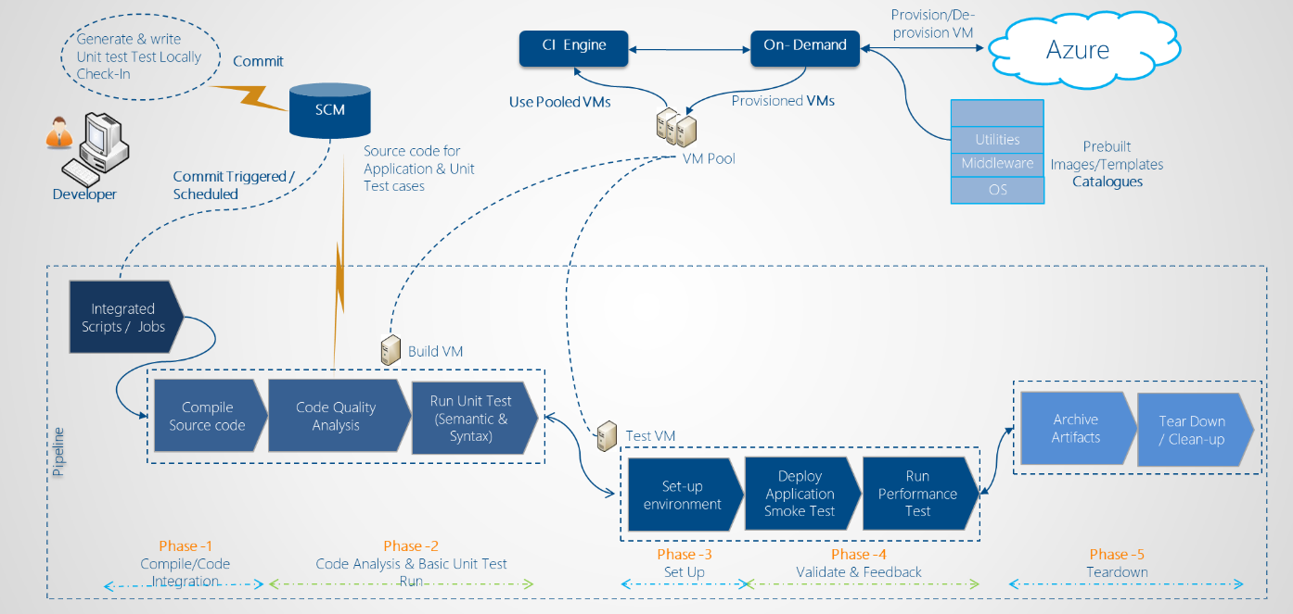

Performance Tests will be conducted as per the below framework:

**Single User Transaction** – Test executed by the developer to ensure unit or component developed adheres to Response Time requirements

**Baseline Testing -** Targeted test scenario testing with fixed users designed to determine the baseline or “best case” response times for the applications business transactions. This is done in an integrated environment as part of Epic level testing

User story testing is performed by QA team for acceptance criteria. EPIC level test cases are tested for performance at transaction level and the load, as applicable.

**Concurrency Testing -** This testing will consist of varying workload levels with the target concurrency. This is done as part of Performance testing on a fully integrated system.

**Load/Stress Testing -** This testing will consist of varying workload levels and test scenario mix to measure and evaluate the performance behaviours and abilities of the system. This testing will also be designed to determine any limitations on the system and ensure the application will continue to function properly under varying workloads.

QA team will work with operations and analysts team to identify the critical business transactions and the performance impact due to the anticipated loads.

Metrics from the existing implementation (for last 1 year) are taken and baselined. Each user story is evaluated for performance requirements and its impact on user transactions and the peak load.

Performance testing on higher environments is performed with actual load and spread of load by transactions.

**Endurance Testing -** This testing will consist of executing tests at a sustained average load to identify memory leaks exist, if any.

## End-End testing

During the sprint testing, QA team would begin outlining the test scenarios based on the end to end system and functional workflow. End to End test scenarios will be designed based on the following critical factors:

* Business process workflow (downstream integrations)
* Positive & alternate path workflows (to ensure test coverage)
* State specific workflows (cover state specific rules/variations)
* Key business functions coverage along with necessary integration points

Test cases would be prioritized as High, Medium, and Low based on the following

* Transaction complexity
* State Complexity
* Business Rules
* Critical workflows & common business functions/operations

End-to-End test suite will test from start by encompassing various scenarios. The objective of these tests is to test the application close to the real-world scenarios. Test team will work with Analysts to identify a suite of test scenarios, which will be automated as part of End-to-End tests. Testers will also be re-use existing functional test cases and explore the option of stringing them together.

All end to end test scenarios are mapped to primary functionality and all other secondary functionalities as part of the end to end flow

End to end scenarios includes NBUS, Endorsements, Cancel, Rewrite, Reissue, Renewal, Reinstate, OOSE, Premium, Billing, Claims, Forms and user roles validation

A subset of critical path scenarios to be identified to validate EDW, UW and Financial reports. Coordinated data identification for end to end testing with these systems will planned ahead of the schedule.

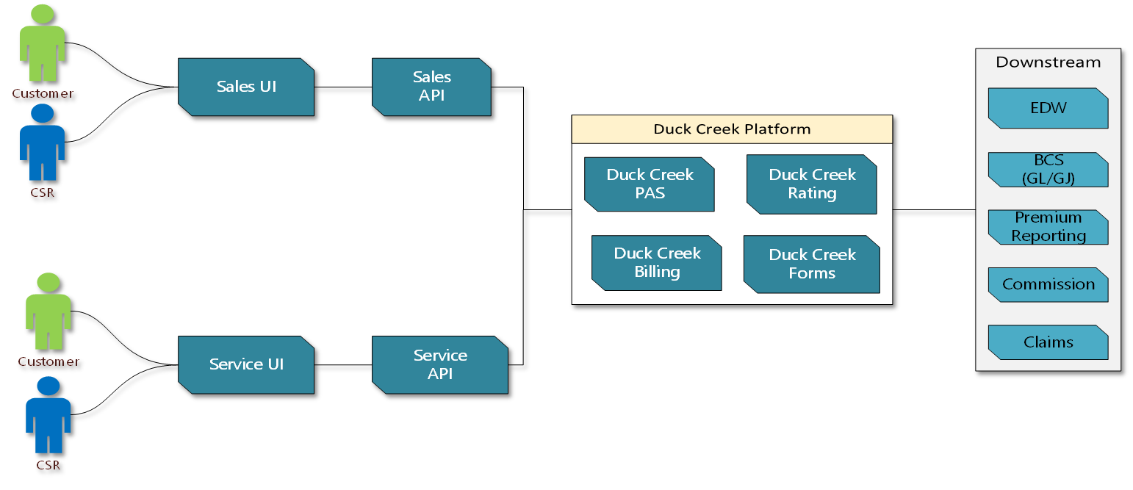

Individual functional testing and then forming E2E test cases

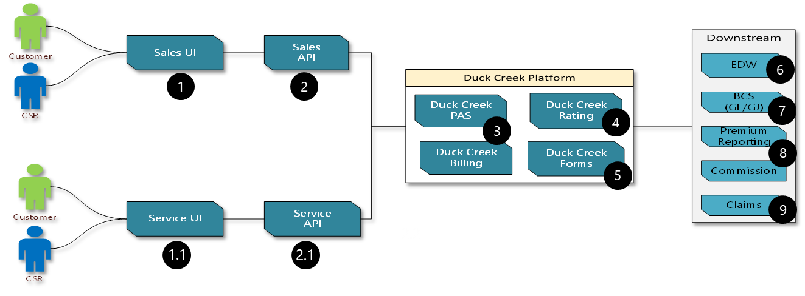

|  |  |  |  |
| --- | --- | --- | --- |
| Flow | Application | Toolset | Focus areas |
| **1 and 2** | Sales UI & Sales API | ETF | UI and Service testing |
| **1.1 and 2.2** | Service UI & Service API | ETF | UI and Service testing |
| **3, 4 and 5** | Duck Creek PAS/Billing/Rating | ETF and TAC | Rules, Rates and Express UI validation (if required) |
| Duck Creek Forms | ETF, TAC, PDF Compare | Forms validation at User story, Feature and EPIC level |
| **6, 7, 8 and 9** | Downstream applications | Coordinate with downstream test teams to validate critical data flows  Automate downstream validation based on feasibility  Toolset will be finalized post feasibility analysis | |

## UAT

Guidelines for UAT

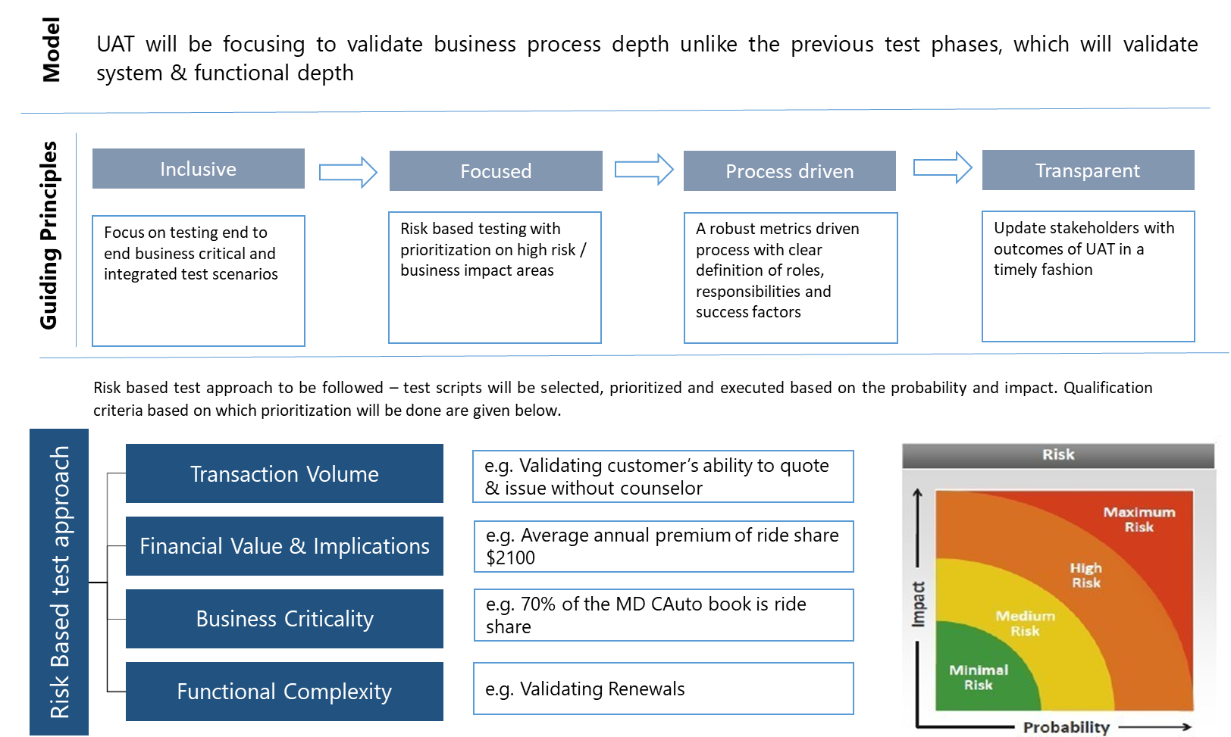

Assigning defect severity will differ between functional test phase and UAT – given below are the guidelines for defect severity assignments.

|  |  |  |  |
| --- | --- | --- | --- |
| S.No | Severity | Description | Example |
| 1 | Critical | * Business will be severely impacted because they cannot proceed with a major part of functionality * Catastrophic System Failure.  No further processing is possible * The issue blocks a significantly high volume of UAT test scripts for a core system (Duck Creek) in the scenario navigational path because the data from a dependent application or interface cannot be processed * It is determined that this defect will risk testing schedule and there is no alternate work around/mitigation to recuperate from the delay * It’s been determined that the functionality impacts customer critical components and will severely impact customer satisfaction, agent experience or the financial and regulatory aspects of the  business | * Entire Server goes down and the URLs don’t work * User authentication service is broken and users cannot log into the system * Critical rating errors blocking quote and bind * Policy processing cannot continue because account cannot be created, there is no existing account * Environment unavailability |
| 2 | High | * Business will be impacted because selected functionality is not working and has a limited work around * It’s been determined that the functionality impacts customer critical components and will adversely affect customer  satisfaction, agent experience or the financial and regulatory aspects of the  business | * Incorrect premiums are sent to customers * Billing errors on the invoice like incorrect billing amounts, incorrect due dates * Premature delinquency failures, company cannot send delinquency letters * A legal and financial report or document sent to the customer doesn’t have the proper legal verbiage that is necessary for legal protection * Premiums charged are significantly less than expected, it might impact company’s financial outcomes * Regulatory reports have missing key fields which are necessary for the regulators to assess compliance |
| 3 | Medium | Non customer critical or non-business critical issues which will not have a far reaching customer , regulatory, financial or legal impacts | * Non critical customer information is truncated in documents, it doesn’t have any legal impact * System is sending incorrect non-financial information to legacy |
| 4 | Low | Minor cosmetic change affecting internal customers only | * Field labels have minor mismatches * Warning message is incorrect or obscure * Errors from an integration are not user friendly |

**UAT Entry criteria**

|  |  |  |
| --- | --- | --- |
| Criteria | Condition | Evidence by |
| Predecessor deliverables | Pre-requisite deliverables signed off by respective stake holders   * Master test strategy, epics, business requirements, process maps, personas & journey maps | Status / Sign-off from business and system test leads |
| Development &  End to End System Testing | * Development and testing complete for all User stories (done) in scope * E2E System test execution complete   + No open defects with critical or high severity   + Agreed workaround for medium & low severity defects | * User Story status from Azure DevOps * E2E ST Completion report |
| UAT Artifacts | * Strategy created, reviewed & approved * Plan created, reviewed and approved * Scenarios created, reviewed and approved * Respective test scripts created and reviewed prior to each cycles * Request relevant E2E System test outputs for verification. e.g.: Policy #s, forms, test execution logs | * Approval documentation for UAT strategy, plan & scenarios |
| Users (UAT Resources) | * UAT testing and business resources are identified, available, trained and staffed | * Staffing Plan |
| User configuration,  Test Data | * All needed roles & permissions are configured in UAT test environment * Test data   + Agreement on process and communication plan between UAT & TDM teams for requesting & receiving test data.   + Test data request shared with type of test data and volume | * UAT Test strategy * Test Data request log |
| Test Environment | * Environment calendar with the information below are published, reviewed and agreed * Known environment downtime * Service down test schedule * Flow calendar with system and policy effective dates * Code drop and / or DB drop schedule (if any) * Environment reset (if any) * Test Environment incident reporting and support approach is defined, reviewed, implemented and approved * User Acceptance Test Environment has been delivered with: * All standard pre-handover tests completed * Shakeout activities agreed and assigned | * Environment calendar * Environment Shakeout test results |
| Configuration & Release Management | * Agreement on code deployment schedule – no new functionality or feature to be introduced without prior agreement and approval. Builds will include only defect fixes * Configuration and Release Management approach is defined, agreed and implemented. * Provision of a release note detailing: * All relevant code libraries/versions of code * Defects with fixes * Installation patches or changes * Versions of configuration data | * Build & deployment schedule * Release notes |

UAT Exit criteria

|  |  |  |
| --- | --- | --- |
| **Criteria** | **Condition** | **Evidenced by** |
| Test Execution | * All tests defined within the UAT execution scope post Risk Based Testing analysis has been executed | * Test Execution log |
| Defect Management | * All critical & high severity defects have been fixed and successfully retested * All medium severity defects with higher priority (based on business impact assessment in triage) are documented & have workaround(s) * All medium severity defects with lower priority and low severity defects are documented | * Azure DevOps |
| Test Completion report | * Test Completion Report created and distributed with test metrics, outstanding defects, outstanding areas of risk and results based inputs/recommendation for program level ‘Go or Not to Go’ live decision making process | * Test completion report |
| Document Management | * All required test evidence and artifacts are stored within the agreed configuration libraries maintained within Azure DevOps * Test scripts and results are stored and maintained in Azure DevOps | * Azure DevOps |

# Environments and tests conducted

|  |  |
| --- | --- |
| List of Environments | |
| Environment | **Purpose** |
| SB1 | Sandbox environment |
| IN1 | Integrated environment with rest of the downstream and integrated systems |
| UT1 | User Sign-off |
| LT1 | Load Testing |
| TR1 | Training counsellor before feature release to production |
| PD1, PD8 | PD1- Azure East (Primary Production)  PD8- Azure west (applicable based on business criticality of the application hosted on Azure) |

*\* list of environments for Commercial for other applications in scope for testing, this list will be revisited*

Following table details the frequency and timelines for different types of testing:

*(will be reviwed with Analyst team)*

|  |  |  |  |  |  |  |
| --- | --- | --- | --- | --- | --- | --- |
|  | ENVIRONMENT – TEST Type Mapping | | | | | |
| **Type of Testing** | **Frequency** | **SB1** | **IN1** | **UT1** | **LT1** | **TR1** |
| Smoke Test | Each Build | ✔ | ✔ | ✔ |  | ✔ |
| Functional (Acceptance criteria) | Each Sprint | ✔ | ✔ | ✔ |  |  |
| Integration Testing | Each Sprint |  | ✔ |  |  |  |
| Continuous Testing | Each Sprint |  | ✔ | ✔ |  |  |
| Mobile - Tablets | Planned Sprint |  | ✔ | ✔ |  |  |
| E2E test cases | Planned Sprint |  |  | ✔ |  |  |
| Responsive UI testing | Planned Sprint |  |  | ✔ |  |  |
| UAT | Before production |  |  | ✔ |  |  |
| Load Testing | Before production |  |  |  | ✔ |  |
| Counselor training | Before production |  |  |  |  | ✔ |

# Test data management

A key activity during preparation for testing is to gather and manipulate test data. Various types of test data are involved, including user test data and the expected result test data used for comparison. For functional testing, a set of known input data and the expected output need to be ready as part of the test criteria. Test Team will rely on the analysts and their subject matter expertise to compile appropriate test data. In addition, at Indy IT CoE QA team will employ test data management by leveraging CA TDM.

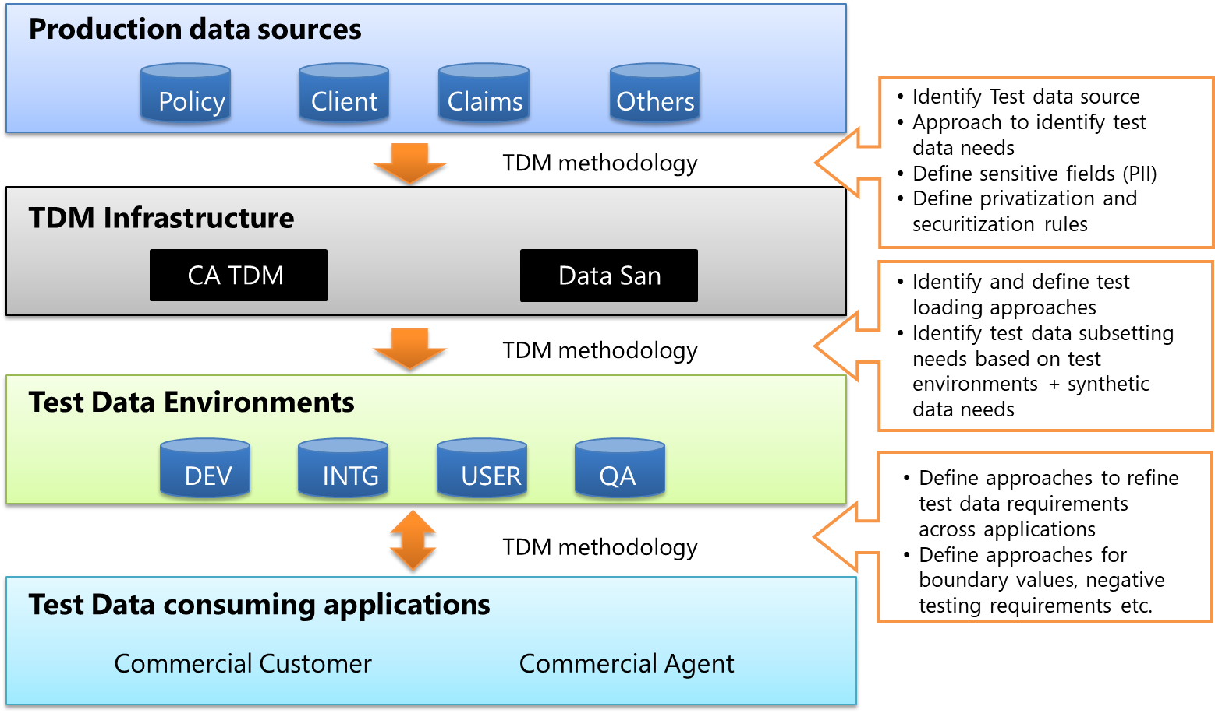

## Technical architecture diagram

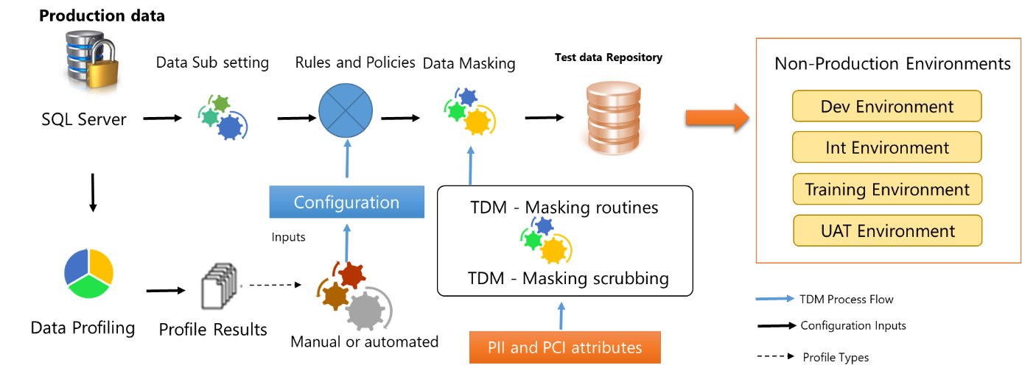

SQL Server database – Dump of all production policies available for multiple commercial lines polices

Data sub setting, Rules and polices, Data masking, profiling can be performed with CA TDM tool available in house at GEICO

## Data masking

This section details the minimum list of PII and PCI compliant fields masking required to use in test environment

|  |  |  |
| --- | --- | --- |
| DATA ELEMENT | DESCRIPTION | REQUIREMENT TO ENCRYPT |
| Name | Full Name, maiden name, mother's maiden name, or alias | No- As long as only other sensitive element available in an unencrypted state is the year of birth |
| Street Address *(except state and zip)* | House Number, Street Name, Apartment /Suite # | Yes-Only House Number, Street Name, Apartment / Suite# |
| Phone Numbers | Home, Cell, or other personal phone numbers provided | Yes- Maintain last 4 digits unencrypted |
| Birth Date | Birth date of the individual, only if it can be related to a specific individual | Day and Month - Encrypted Year - unencrypted |
| Social Security Number | U.S. issued Social Security Number | Yes- Maintain last 4 digits unencrypted |
| Driver’s License Number | State or international driver’s license number | Yes-Maintain last 4 digits unencrypted |
| SID Number | Other state or government issued identification number such as ID card, passport number, taxpayer identification number | Yes- Maintain last 4 digits unencrypted |
| Credit Card Number | Handled by GEICO Standard Credit Card Tokenization process | Yes-Tokenization |
| Debit Card Number | Handled by GEICO Standard Credit Card Tokenization process | Yes-Tokenization |
| Bank Account Number | Bank account numbers associated with the individual(s) | Yes- Tokenization |
| Email Address/alternate email address | All email addresses associated with the individual | Yes |
| Credit scores - if associated with Name | Individuals credit scores | Yes |
| Vehicle Identification Number | Leave first 11 unprotected and last 6 protected | Yes- Leave first 11 unprotected and last 6 protected. Can do partial masking so it passes edits, but can’t be looked up to get rest of owner’s information |
| Vehicle Tag Number - if associated with Name | Tag / License plate numbers for vehicles | No |
| Medical Insurance Information | Provider, Plan #, Member ID, etc. | Yes |
| Medical records and Health Information | All medical information about an individual. Includes, but is not limited to FML, procedures, injuries, treatments, etc. | Yes |
| Dependent information | All sensitive data elements for dependents of individual | Yes- Use the encryption criteria for the type of data element |
| Background Checks | Information returned from background checks | Yes |
| Biometric data | Including photographic image (especially of face or other identifying characteristic), fingerprints, handwriting, or other biometric data (e.g., retina scan, voice signature, facial geometry) | Yes |
| Data obtained from CLUE/MVR | Data obtained from CLUE and MVR reports on individuals. | Yes |
| Remuneration data | Salary, Bonus, Profit Sharing, and other compensation / payment information | Yes |
| User ID and Password | There should be no User IDs or passwords stored in a GEICO created system. GEICO systems should leverage other systems (Active Directory, ForgeRock, etc.) in order to provide User ID and Password Management | Yes |
| Security Questions and Answers | There should be no security questions and answers stored in a GEICO created system. GEICO systems should leverage other systems (IDM, Active Directory, ForgeRock, etc.) in order to provide User ID and Password Management | Yes |

The process of data masking is defined in the attached link from CA

Reference: <https://docops.ca.com/ca-test-data-manager/4-2/en/provisioning-test-data/mask-production-data/fast-data-masker-best-practices>

## Stub data in lower environments and utilize true integration data later

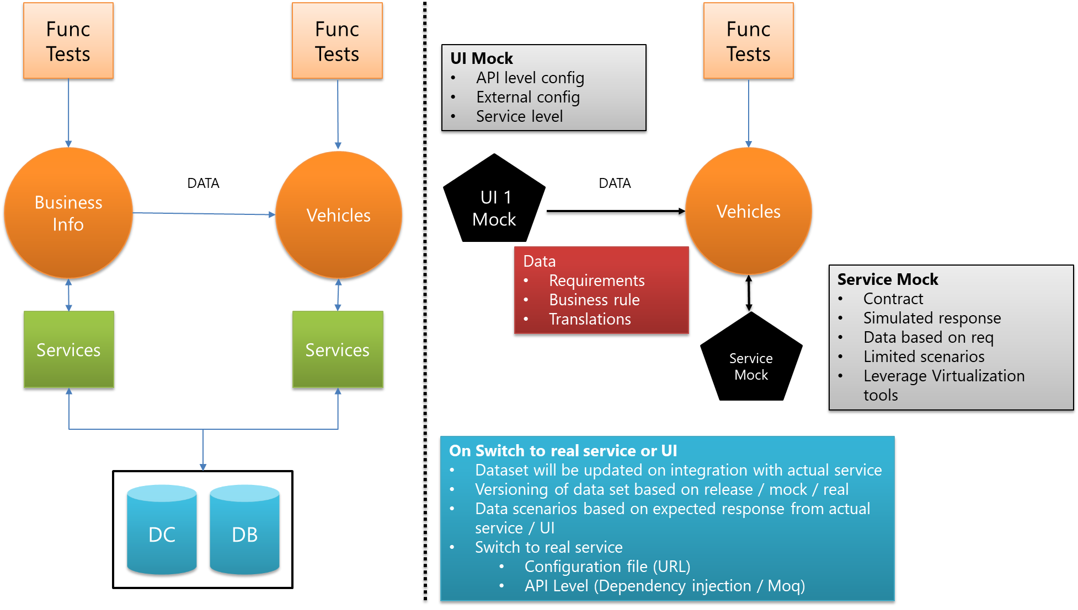

## Synthetic data generation

CA TDM Portal lets you create Data Generators for the projects created in CA TDM Portal (recommended) or Datamaker. The Data Generator includes the functionality to create data generation rules and publish synthetic data.

Use the Test data generation functionality in the CA TDM Portal to create data generation rules. These rules include data functions that help you generate synthetic data when you perform the [data publish](https://docops.ca.com/ca-test-data-manager/4-2/en/provisioning-test-data/generate-synthetic-test-data/generate-data-using-the-ca-tdm-portal/publish-data-using-the-ca-tdm-portal) operation. At the time of data publishing, the CA TDM Portal evaluates each column and resolves the rule that is applied to each column. The application then populates the column with the value that is generated based on the defined rules.

Testing with (copies of) production data only permits low variance (few edge cases). Testers need to avoid over testing common cases, and undertesting edge cases. There are more combinations than you can possibly test. Identify which columns are relevant which cases you want your tests to cover, and what you consider 100 percent test coverage (e.g. Vehicle types).

The Test Data Visualizer is a business intelligence-like utility that is designed to help you build better test data. Use it to identify missing combinations of data, analyze invalid sets of combinations, and compare the coverage of different environments (production data compared to QA data, compared to DEV data). The utility lets you measure coverage accurately and track progress. Data visualization is an essential tool for understanding where you want to generate synthetic data to ensure that you have sufficient data coverage across your test repository.

Ideal candidates for coverage visualization are columns that have only few, unique values (such as languages, currencies, user roles, or account types). You do not use it to visualize columns that contain large sets of unique values (such as names, IDs, addresses, phone numbers) because the result would be meaningless. Look at your test plan to identify the relevant test data attributes, and create a flattened abstraction of relevant columns to run the visualization on.

Reference: <https://docops.ca.com/ca-test-data-manager/4-2/en/provisioning-test-data/generate-synthetic-test-data/generate-data-using-the-ca-tdm-portal/create-data-generation-rules>

## Rate testing test data support

For rate testing, data elements that is tied to rating attributes & rating factors (For example, Location, City, State, County, Zip Code, driver DOB, etc.) should remain same. This should give comparisons of rates from old state to the new state. However, the financial data (for example, Fed ID, SSN, Name of the insured, etc.) that requires to meet information security standard and policies needs to be masked, subset and synthesized.

Team should / would develop data scrubbing strategy that will protect sensitive data by replacing it with fictitious but realistic and structurally similar data. This will provide test data sub-setting, data masking, and synthetic test data generation and data refresh to application teams, that matches real production data, but is scrubbed for privacy compliance.

Following activities will help in define the TDM strategy –

* Review test data need (application /functional testing, rate testing, Integration testing, data period requirements, etc.)
* Analyze source data using data models, metadata
* Identify sensitive data elements that requires to be masked or synthetically generated (depending on the policy type)
* Create data mapping with subset, masking & synthetic data generation rules using TDM tool
* Apply the same masking transformations against data regardless of the application, database, or operating system.
* When the masked attribute serves as a key, apply the same change (old -> new) throughout enterprise application data so that no relationships are broken.

## Time travel testing test data support

For time travel scenarios, best practice is to start from current date and move the date forward up to 15 – 20 years. Most application support moving dates forward. The date movement back even though not restricted by applications / environment, could muddle the transaction data. It is always recommended to perform database drop before moving the date back to current date.

Additionally, for SIT and UAT testing, it is also recommended to create calendar for testing execution. This will require coordinated test by the users / QA team(s) by entering all the scenarios simultaneously. Plan the sequence of execution of scenarios with emphasis on testing real production like policy conditions. Users can test multiple applications (Policy, Billing, Claims, etc.) and scenarios simultaneously at the same time by entering test data for all test cases / test scenarios together. Test everything in one execution cycle by skipping dates that does not require any transaction or verification steps. Additionally, run complete batch cycle (EOD, EOM, EOQ or EOY) before every date change, for controllers and accounting teams to verify their data.

* Plan the sequence of execution with emphasis on trying to front load complex test cases as early as possible
* Allows user flexibility as all users are not required to be available all the time for UAT.

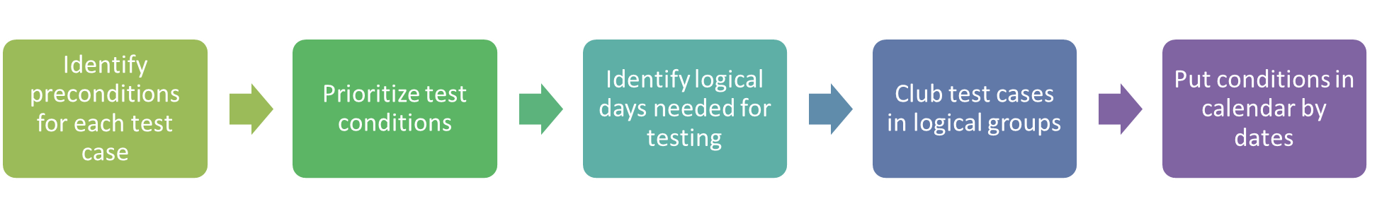



## Data refresh

All imported, generated, and augmented data is stored in a central repository. Test team can then extract, clone, and deliver re-usable subsets of data to the teams on demand, eliminating data dependencies and maximizing the value of work already done.

Also, this enables Data reservation which means that testers receive the data they need from multiple systems, eliminating the time otherwise wasted looking for or preparing data, or creating it. They can request the exact data they need, and have it automatically delivered from the central repository in parallel and on demand.

QA program lead onsite, VM offshore leads, Test automation architect and other stakeholder from GEICO constantly evaluate the test data needs of multiple scrum teams on regular basis (due to evolving functionality). Test data needs are identified and subset requirements are documents to ensure proper subset test data is made available to respective Scrum teams e.g. Commercial Modernization and Mobile automation test team needs are different frome one another.

Test data refresh frequency depends on the project life cycle stage due to the nature and subset granularity.

|  |  |
| --- | --- |
| Environment | Data refresh criteria |
| Developer local systems | Every Sprint or more often e.g. 2 times within each Sprint. If developers access a test data environment then the frequency is as per SB environment frequency as mentioned below |
| SB | Every week as there will be regular builds to SB environment for unit testing and regression testing of previous Sprint functionality |
| IT | 2 week frequency to support Product demo at the end of each Sprint and support regression testing of previous Sprints |
| UT | 2 week frequency to support testing (automated) of acceptance scenarios and demonstrate the coverage and data variations tested against critical user requirements like 1) Compliance requirements 2) Acceptance criteria 3) Edge cases 4) Exploratory scenarios |

Reference: <https://docops.ca.com/ca-test-data-manager/4-5/en/getting-started/key-use-cases>

# Metrics and Reporting

Testing metrics will be published on defined frequency throughout the project duration to showcase the progress made and if there are any risks impacting planned work.

|  |  |  |
| --- | --- | --- |
| Report | Purpose | Frequency |
| Weekly Status Report | Progress report and status of milestones, risks and mitigations | Weekly |
| Requirement Traceability | Demonstrate overall test coverage of documented requirements/user stories, configurations and integrations. | Once every Sprint |
| Test Design Dashboard | Provide status on the number of tests designed for User Stories in the sprint scope and the pending User Stories | On-demand in VSTS- Azure DevOps |
| Test Execution Dashboard | Provide status on planned and executed test cases. Reports overall progress against total number of test cases in scope. This dashboard will also provide a cumulative total of passed and failed test cases and help indicate a trend for completion of testing. | On-demand in VSTS- Azure DevOps |
| Defect Dashboard | Status and defect ownership - indicates defect aging, root cause analysis and severity of the defects identified during test execution. | On-demand in VSTS – Azure DevOps |
| End of phase (Sprint/Release) Summary report | A summary report of the overall status of test execution – will include the total number of tests planned, executed and their overall status. Report will also include a summary of critical/high open defects for stakeholders review and sign-off | At the end of a Sprint/release phase – Azure DevOps |

Following ceremonies as part of the release testing effort:

|  |  |  |  |  |  |
| --- | --- | --- | --- | --- | --- |
| **Meeting** | **Description** | **Frequency** | | **Participants** | **Metrics** |
| Sprint Planning | Sprint planning to plan the testing effort for the Sprint | | Sprint | Scrum Master  Product Owner  Business Analysts  Developers  Testers | Velocity |
| Daily standup / Scrum meeting | This meeting will be held daily to review progress and understand risks or impediments | | Daily | Scrum Master  Product Owner  Business Analysts  Developers  Testers | Planned vs. Completed work |
| Weekly QA Meeting | This meeting will be held to update the Testing Status for the week | | Weekly | QA Lead  QA team members | Test Design Productivity  Test Execution Productivity |
| User Story/ Requirements walkthrough | BA will conduct these meetings to provide walkthrough of User Stories | | Sprint-1 | Business Analysts  Developers  Testers | NA |
| Daily triage meetings | Will be conducted by QA lead to review the defects | | Daily | QA Lead  Scrum Master  BA  Dev Lead  Testers | # of critical defects  #of slipped defects |
| Sprint Demo | To demo the features developed | | Sprint | Scrum Master  Product Owner/Business  Business Analysts  Developers  Testers | Feature Planned vs ready |
| Sprint Retrospection | Continuous Learning and Adapting | | Sprint | Scrum Master  Product Owner  Business Analysts  Developers  Testers | NA |

Custom public queries will be created in Azure DevOps/VSTS to pull the metrics. This query will be accessible to all Scrum teams and will return the latest updated metrics. There are few sample queries list below:

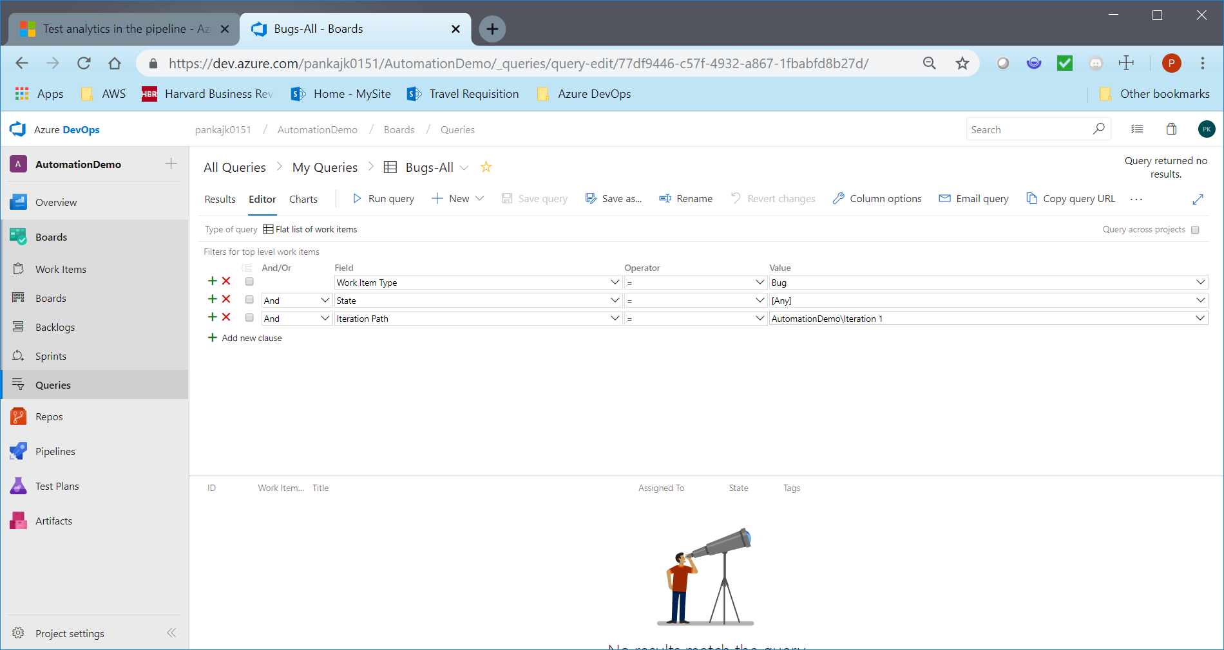

Fig above: All bugs for Iteration1

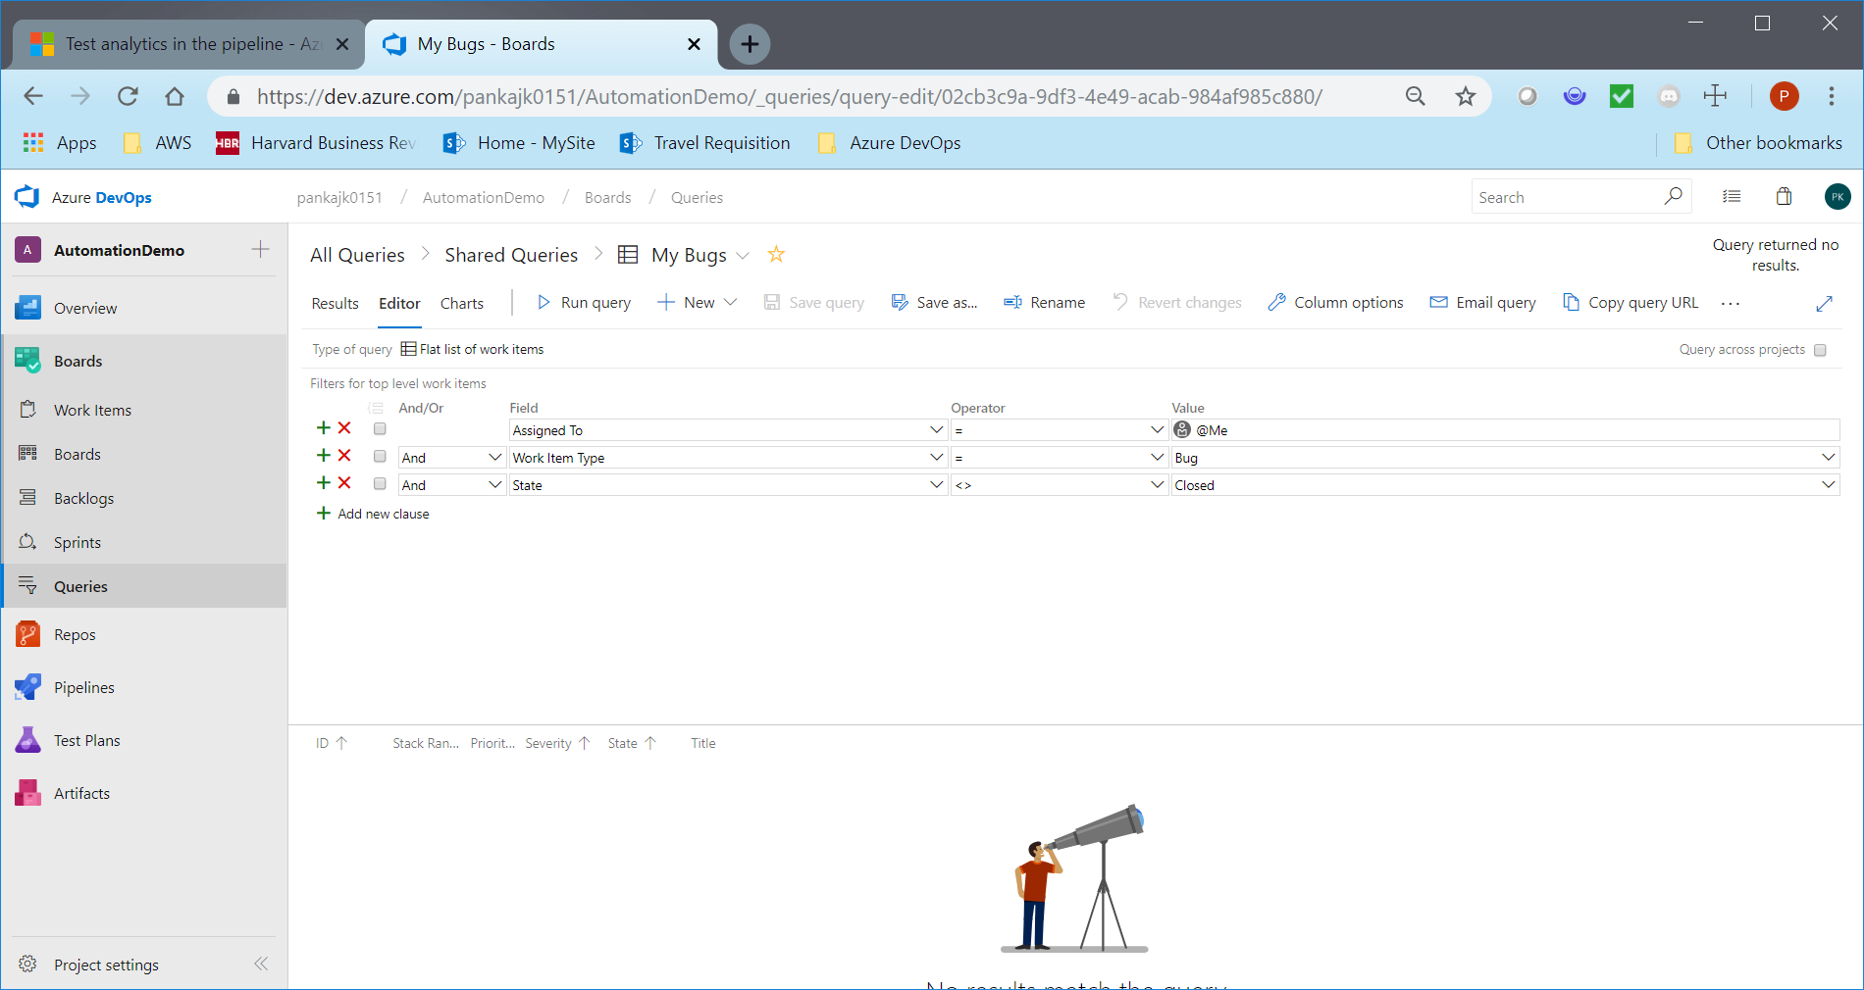

Fig above: All bugs assigned to me

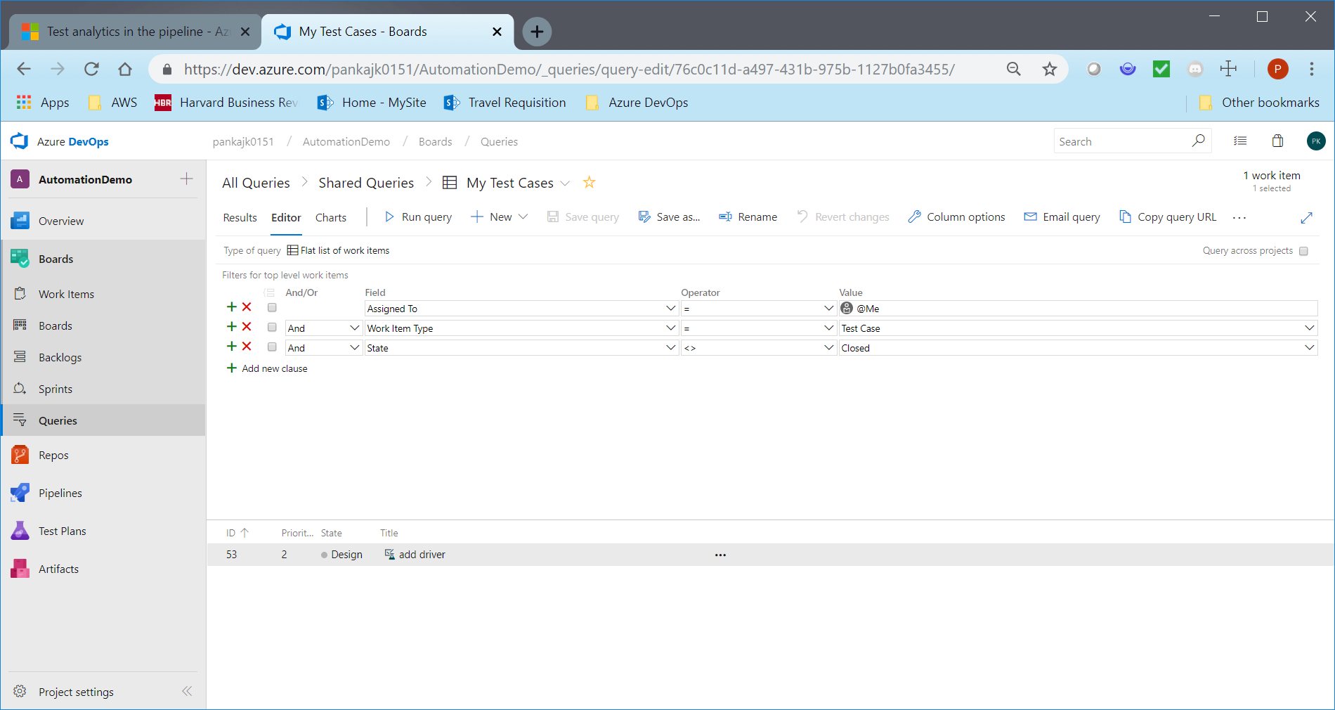

Fig above: My Test Cases

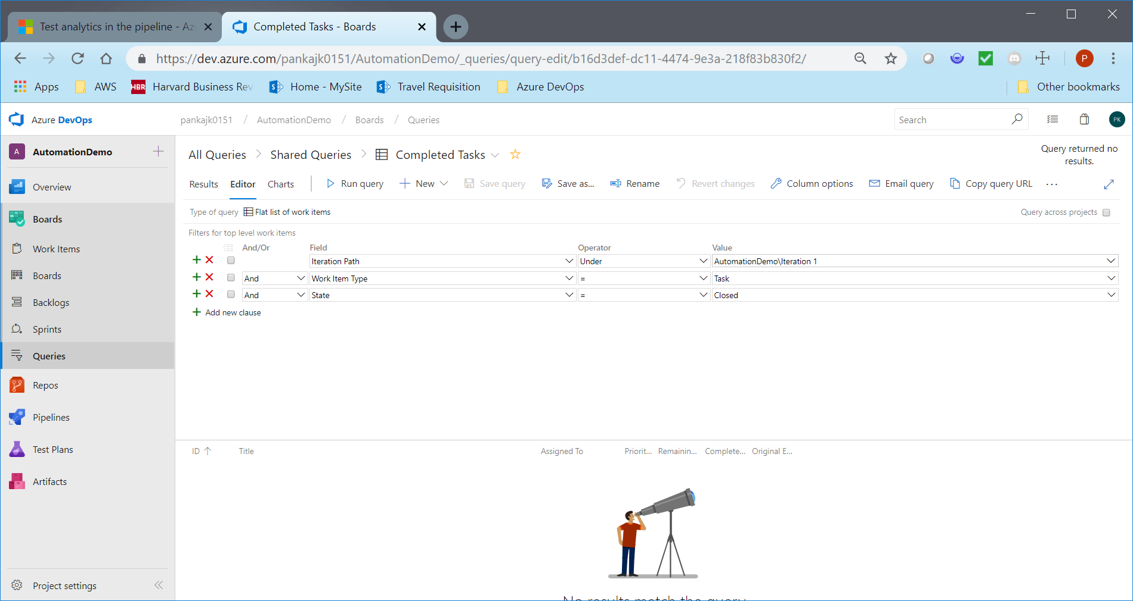

Fig above: Completed Tasks for Iteration1

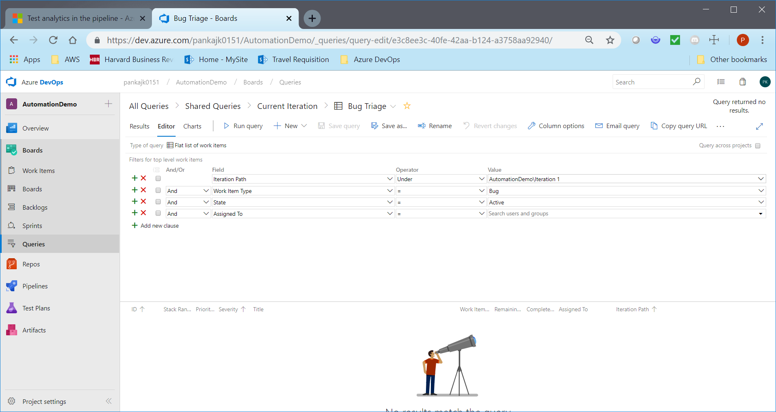

Fig above: Bug Triage

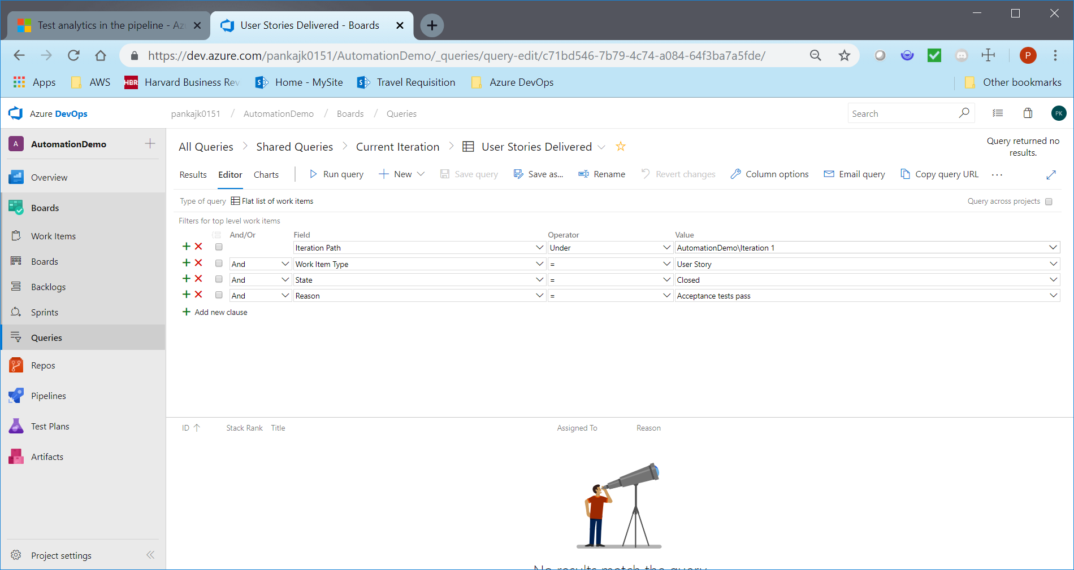

Fig above: User Stories Delivered

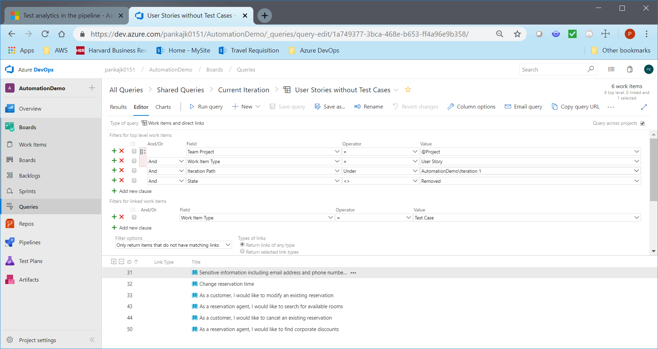

Fig above: User stories without Test Cases

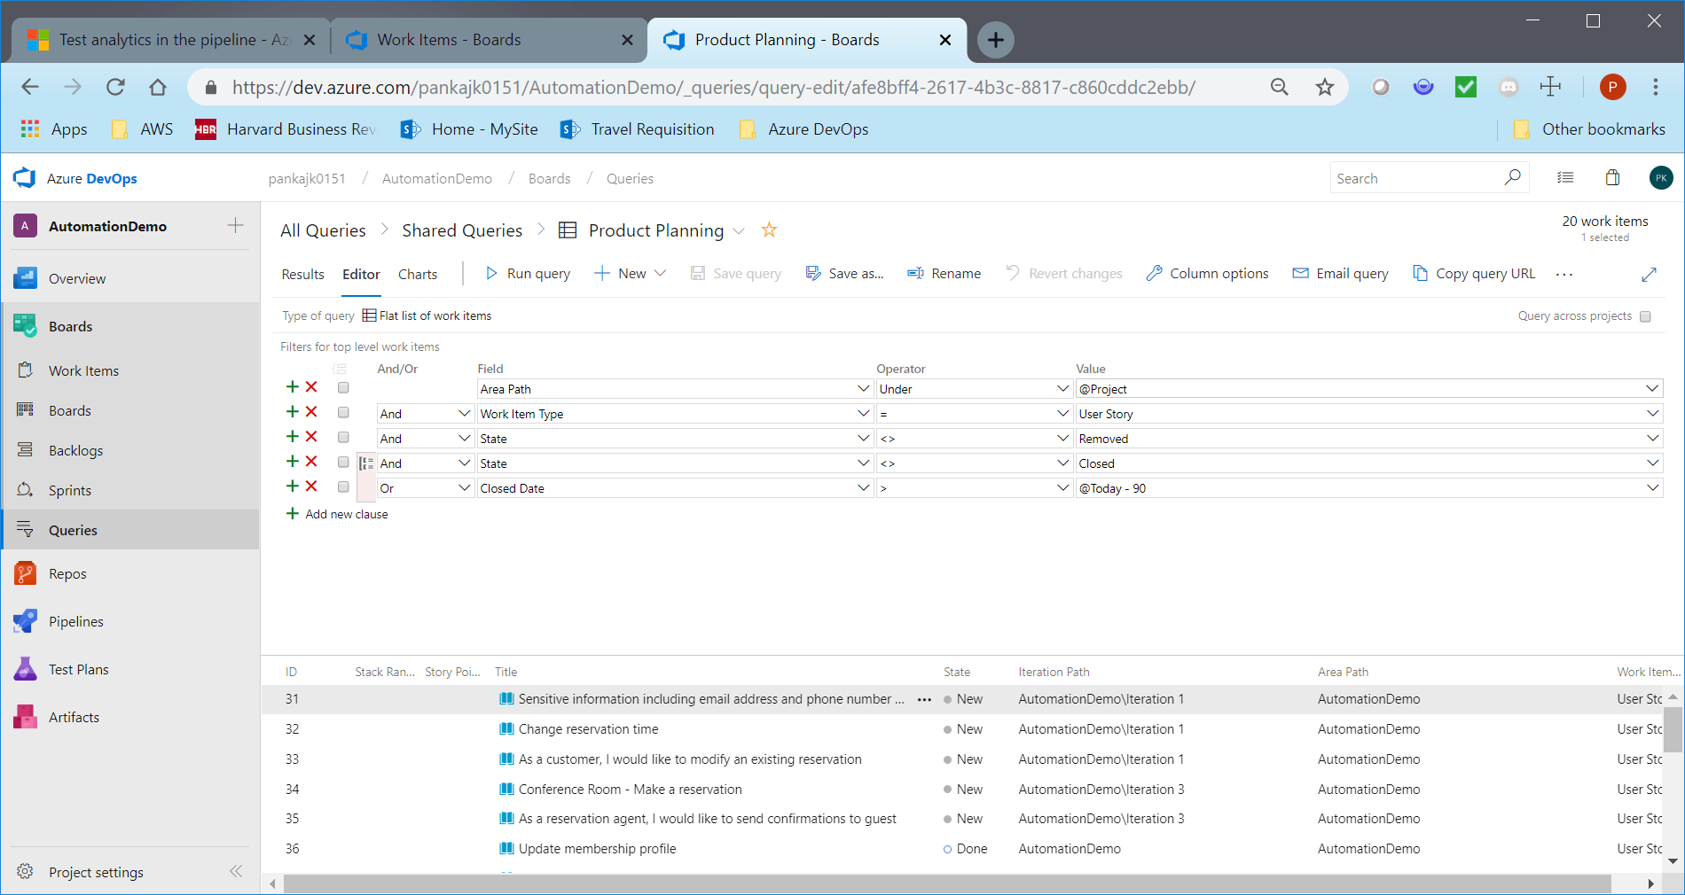

Fig above: Sprint Planning

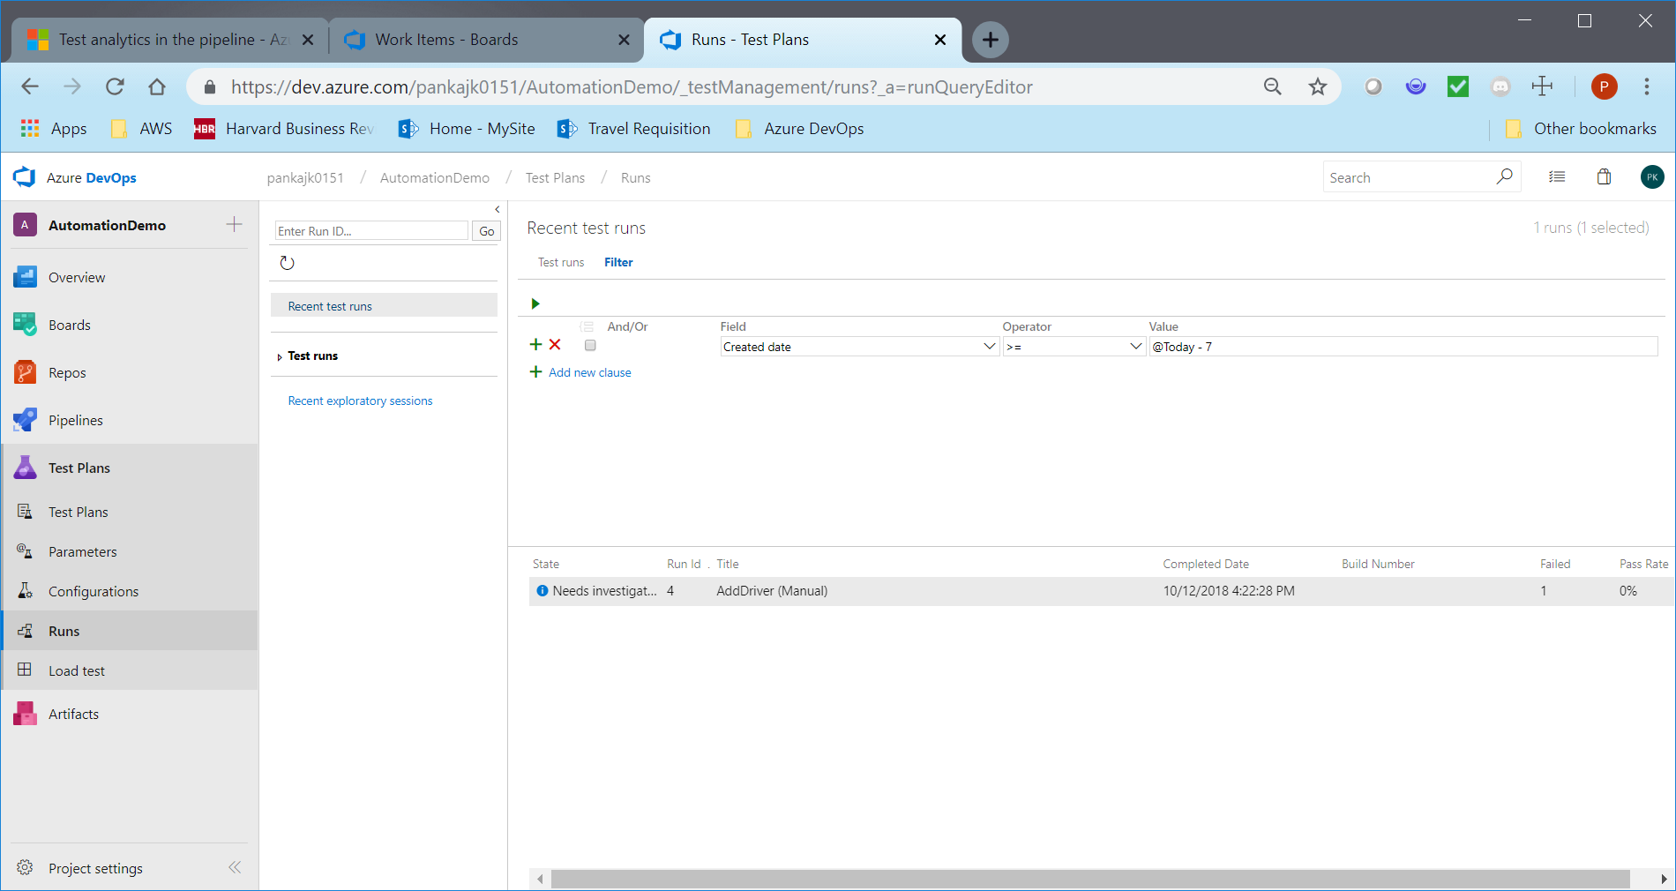

Fig above: Recent Test Run/Execution

Note: The reports above are subject to change due to the changing needs of the program and expectations of stakeholders.

# Traceability

To ensure user requirements meet the quality goals, all user stories will be linked to the test results, this can be easily viewed from the team's dashboard. This enables end-to-end traceability with a simple way to monitor test results.

In the results section under Tests tab of a build or release summary, select the test(s) to be linked to requirements and choose Link.

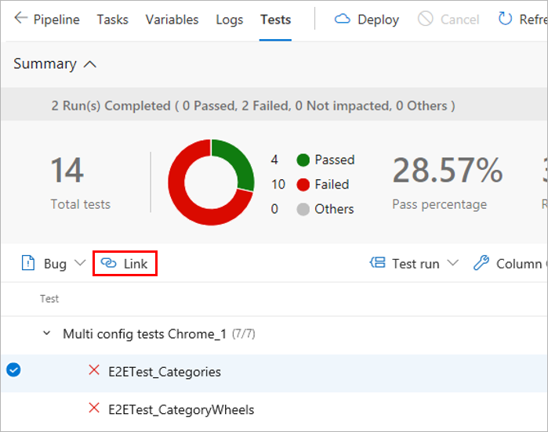

View the bug with the test result, directly in context, within the Tests tab. The Work Items tab also lists any linked requirements for the test result.

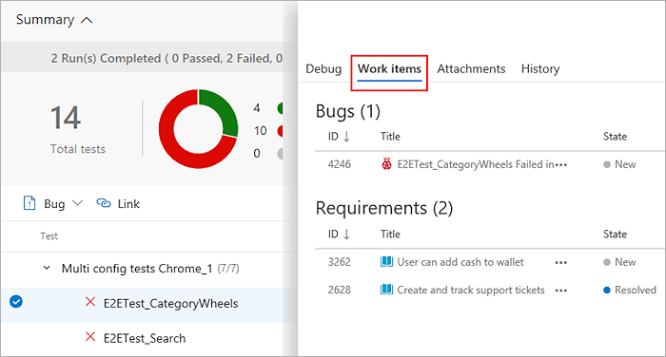

Source Traceability:

When troubleshooting test failures that occur consistently over a period of time, it is important to trace back to the initial set of changes - where the failure originated.

In the **Tests** tab, select a test failure to be analysed. Based on whether it's a build or release, choose the **Failing build** or **Failing release** column for the test

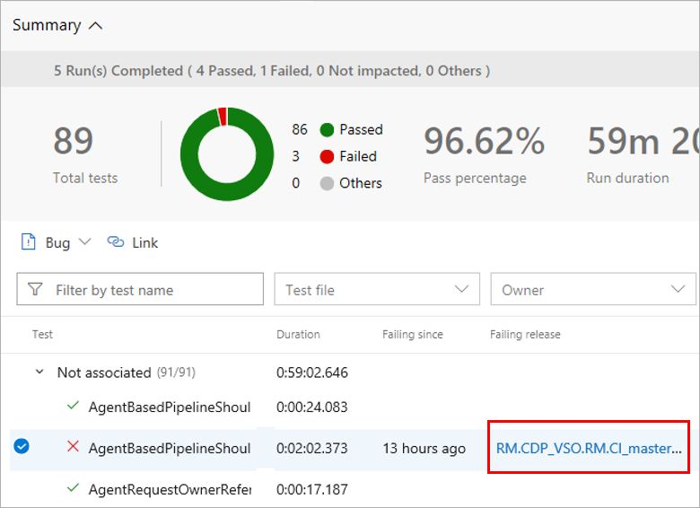

Based on the build or release pipeline, you can choose the timeline or pipeline view to see what code changes were committed. You can analyze the code changes to identify the potential root cause of the test failure.

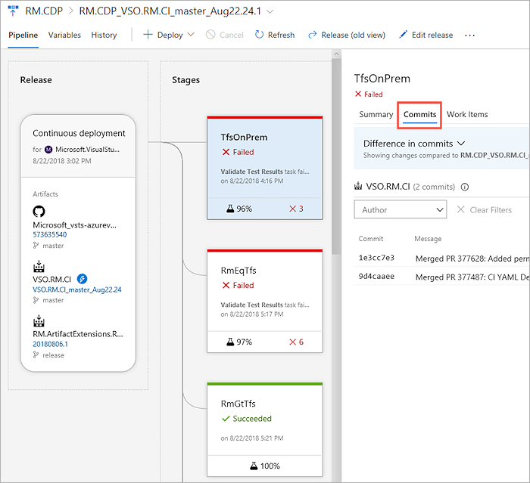

# Defect management

Azure DevOps will be used to keep track, report and analyse defects. Scrum Team will conduct weekly meetings to obtain status, prioritize and review issues. Once the defect is fixed, the test case will be re-executed.

Defect Types

|  |  |  |
| --- | --- | --- |
| Defect Type | Description | Assigned to |
| Application Defect | Defects found in the application that prevent the Test cases/Scripts from running | Assign to Analysts to triage |
| Test Data Issues | Defects found in the test data that prevent the Test cases/Scripts from running. The Test Team determines what the problem is within the test case, notifies the analyst of data issue and corrects the problem either by editing the test data or validating the test data or obtaining new data | Assigned to Test team |
| Test Script Issues | Defects found in the Test Script | Assign to Test Engineer within Test Team. If the problem is that the Test Case does not match the test plan (or specs), then assign to the owner of the Test Script and work with analyst to resolve |
| Requirement Changes | Change Controls for each release will be reviewed by Project Managers and if any accepted Change Control modifies the flow of existing functionality then test scripts will be modified to accommodate the changes. | Assigned to Test team if the Change Controls contain new functionality, the test plans will be enhanced by adding test cases/ scripts to cover that functionality |







|  |  |  |
| --- | --- | --- |
| **Test Team Attribute** | **Description** | **Accepted values** |
| Title | A brief description of the Bug with keywords to identify the Bug | Any |
| Assigned to | The user to whom the Bug is assigned to | Select a valid value from the dropdown |
| State | Field indicating the status of the Bug | Active  Resolved  Closed |
| Reason | Field indicating the reason for the state of the Bug | New  Build Failure  Fixed  Verified  Test Failed  Not Fixed  As Designed  Cannot Reproduce  Deferred  Duplicate  Obsolete  Pending |
| Area | Application area of the Bug | Ex: “Provide the Project area” |
| Iteration | Iteration to which the Bug belongs | Ex: ““Provide the Project area/ iteration or Sprint” |
| Stack Rank | Rank indicating the sequence of the development | Leave blank during submitting the Bug |
| Priority | Indicates the priority of the fix; analysts in consultation with Scrum Master will determine priority | Enter “3 - Medium” as default value if not sure. This will change based on the triage |
| Severity | Indicates how much it is affecting the test progress  0 – Showstopper-> Major functionality not working / Cannot proceed with testing. There is no work around.  1– Critical -> Functionality not working but there is a work around. A work around may exist but its use is unsatisfactory. In general, you would not release the product with such a bug.2- High - > Does not affect our ability to operate, but makes it difficult to work. Workaround may exist but is very cumbersome  3 – Medium -> Bug causes failure of non-critical aspects of the system. There is a work around.  4 – Low -> Bug of minor significance. A work around exists or, if not, the impairment is slight | Enter “3 - Medium” as default value if not sure. This will change based on the triage |
| Responsible | Team member responsible for the bug |  |
| Environment | Environment where the bug was found | Dev.  FastTrack  Integration  Load Test  Prod  QA  System Integration  Training  User |
| Steps to reproduce | Details of the steps to follow to reproduce the Bug | Detailed steps and preferably in sync with the test case steps |
| System Info | Found in Build: Enter the build where the Bug was found  Integrated in Build: Build where the Bug was integrated | Found in Build: Select from Drop down  Integrated in build: Testers to leave it to defaulted value |
| Test cases | Link to the test cases that found the Bug or test cases that are impacted due to this Bug | Link all the appropriate test cases from Azure DevOps |
| All Links | Any additional details on the links |  |
| Attachments | Any attachments which contains the screenshots/documents/etc. |  |

**Naming Convention**

To make querying easy for everyone, there will be a standard naming convention for the internal testing process. The test team is already using the below, which can be adopted for internal testing going forward:

* B: FT Defects found in sprint functional testing
* B: RT Defects found in sprint regression testing
* B: ET Defects found in exploratory testing
* B: ST Defects found in system testing
* B: UT Defects found in User acceptance testing

# Risks and Mitigation

|  |  |  |  |
| --- | --- | --- | --- |
| **#** | **Risk** | **Impact** | **Mitigation** |
| 1 | Environment availability | High  schedule impact | Upfront planning with architecture team and check the availability of necessary environments at least 2 Sprint ahead. |
| 2 | Availability of the Test Data from the TDM environment provide for different test needs | Medium  Increased effort required, schedule impact | QA team will identify test data and create test data spreadsheets in a format that is readable by the automation scripts. Automation scripts will be leveraged to key in data from the UI. |
| 3 | DC Template upgrades during ST and UAT phases | High  Scope, schedule, cost impact | Joint risk to be managed with Requirements team, Project managers and Duck Creek team. |
| 4 | Base defects and known issues in the OOTB Duck Creek product could prevent us from executing test scenarios | Medium  Schedule impact | VM Test Leads work with the Duck Creek team to resolve outstanding OOTB defects. |
| 5 | SMEs uncover additional changes to Business Requirements during test design or additional changes or missed requirements are uncovered during Sprints | High  Scope, schedule impact | Requirement updates will be managed via the defined process and the Change Request process. |
| 6 | Impact of conducting date driven workflow and batch testing in Policy and Billing on other test data. | Medium  Data corruption; frequent data refreshes required, schedule impact | QA team to consult with all the stakeholders to explain the approach for managing environment and data.  Manage test executing through a day wise test execution calendar. |
| 7 | Test Impact analysis not supported Microsoft Azure DevOps for Testing of ETF test cases | Medium  Increased cycletime lines | Continuous manual regression optimization and monitor the test automation execution cycle times |

# Assumptions and dependencies

Testing team assumes the following to carry out testing as part of this program:

* User Stories with acceptance criteria made available to the QA team a Sprint (n-1) ahead
* Additional testing effort will be needed to make changes to test design to support changes to user stories
* Testing team will be provided timely access to all the required test systems, environments, and tools for testing
* Converted data will be used to execute identified test cases once the converted data is available in the required environment
* Test Scenarios will be reviewed and signed-off by business analyst to verify test coverage
* Availability of aAnalyst team time for requirements clarifications, timely sign-off on testing artifacts, defect triage etc. is planned by Scrum master
* The DevOps team will communicate all changes made to the environments. This should also include environment configuration changes
* All builds deployed for testing will have a detailed build/deployment/release notes including the list of user stories or defects being deployed as part of the build.
* Any database drops will be pre-planned and communicated to the entire test team since this will impact test data in the test environments
* Any changes that require addition of new features or any customizations or Defect fixes to ETF (GEICO Enterprise Test Automation Framework), will be taken up by the concerned team
* Testing schedule impacts due to any core products upgrades by the Duck Creek team will be escalated to GEICO management for timely resolution and action